|  |  |  |  |  |
| --- | --- | --- | --- | --- |
| |  | | --- | |  | |  | |  | |  | |
| Impact on Total Market Value of Parcels: Introduction of the Street Car in Downtown Cincinnati  Exploratory Data Analysis, Predictive Analysis and Forecast |
| **K. Rajesh Jagannath**  **Foundations of Data Science** Mentor: Anirban Ghosh 04/15/2017 |

* Table of Contents

1. Impact on Total Market Value of Parcels: Introduction of the Street Car in Downtown Cincinnati 4

Introduction 4

Objective 4

Motivation 4

1. Part I: Data Exploration of the Zones under study 6

Data and Sources 6

Extraction, Transformation and Loading of Data 6

Exploratory Data Analyses 7

Methodology 8

Conclusion (Data Exploration) 10

1. Part II: Prediction of Total Market Value of Parcels 11

Data and Sources 11

Extraction, Transformation, and Loading of Data 13

Feature Selection 14

Data and Analyses 16

Methodology 19

ETL Methodology 20

Standardization 20

Dimension Reduction 20

Forecast Model Development and Selection 23

Prediction 33

Visualization of Results 34

Tabulation of Findings 35

1. Part III: Conclusions and Future Work 54

Conclusions 54

Summary 59

Future Work 59

Acknowledgements 59

Problems Encountered during Development of Methodology 62

# Impact on Total Market Value of Parcels: Introduction of the Street Car in Downtown Cincinnati

## Introduction

The Cincinnati Streetcar is a modern streetcar system designed to link major employment centers in downtown and uptown, connecting through Cincinnati's historic Over-the-Rhine neighborhood.

It will operate 18 hours a day, 365 days a year.

## Objective

The study’s goal is to analyze and predict the “net effect” over the next 4 years on the economy of the City of Cincinnati within a buffer zone around the streetcar route by selecting Total Market Value of parcels from source data sets.

## Motivation

Downtown is Cincinnati’s largest employment center, with approximately 70,000 people working in the area everyday. It has been proven in cities from Atlanta to Seattle that fixed rails in the ground with thousands of potential riders draw new storefronts and businesses, as well as housing. These new businesses provide employment opportunity and boost a city’s tax revenue. Furthermore, the **Annual Taxes** assessed on a parcel is a function of **Total Market Value** of the parcel.

During the construction phase, there may have been inconveniences to the neighborhood. Therefore, there are two camps of opinion -

* One opinion insists that the introduction of the streetcar is disruptive to the neighborhood (crowding, transient population, noise), and
* The other opinion is that it provides advantages such as, easy access to business, shops, dining and commuting to work and home and draws new business, expansion of storefronts, revenue from ridership, permit fees, property tax and restaurant license fee.

Three buffer zones around the streetcar route were established as shown below.

* CORE: The area shown in Red color is the CORE Buffer zone. The Streetcar runs through the center of this area along a North South corridor.
* CENTER: The area shown in Magenta color is the designated CENTER Buffer zone
* EDGE: The area shown in Green color is the EDGE Buffer zone

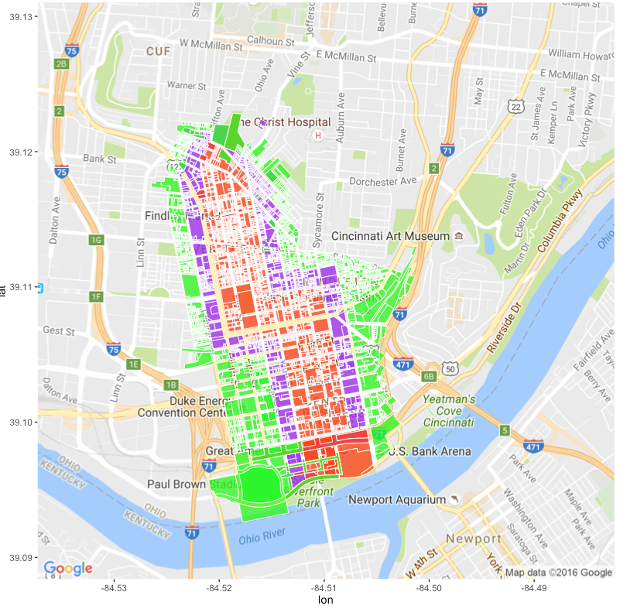

Figure 1 A ggplot of illustrating the buffer-zones CORE, CENTER and EDGE around the streetcar route

This report is organized in 3 parts**. Part I** covers descriptive analytics of the Buffer zone. **Part II** covers a forecast of economic impact due to the introduction of the streetcar system. **Part III** is a conclusion of findings.

# Part I: Data Exploration of the Zones under study

Introduction: Part-I of this report covers the descriptive analytics of the zone under study. The sources of data, its confidentiality, and problems encountered with data, observations and conclusions are reported in this part.

## Data and Sources

**Data sources** were Cincinnati Area Geographic Information Systems (CAGIS), City of Cincinnati, OH and the Hamilton County Auditor Office, Cincinnati, OH.

**Confidentiality of data:** Thedata is considered to be **Open Data** available to general public for use. To be sure, permission was obtained from CAGIS to be able to post the files on github for the purpose of this study

**Buffer Area Parcels: There are three .csv files** with an observation for each parcel in the three buffer zones under study.

* 1. StreetCarParcels_CORE.csv
  2. StreetCarParcels_CENTER.csv
  3. StreetCarParcels_EDGE.csv

## Extraction, Transformation and Loading of Data

Buffer **zone under study**: The three buffer-zone parcel files were in .csv format. It was read in using read_csv. Features to obtain street address and parcel id were selected. The Street address was used to geocode the data to obtain longitude and latitude of the parcel.

| **Column name** | **Example Data** | **Description** |
| --- | --- | --- |
| **PARCELID** | 7500010007 | Unique id to identify parcels |
| **EXLUCODE** | C | Existing Land use Code e.g. Commercial |
| **ADDRNO** | 1208 | Address, street and type of street |
| **ADDRST** | SYCAMORE |
| **ADDRSF** | ST |

**Table 1: .csv files are used to identify the parcel id. of the three areas around the Street Car - Core, Center and Edge Buffer zones**

The data was visualized for exploratory analysis. There are 900-1700 observations in each file. The file size is about 1.2 MB.

* StreetCarParcels_CORE.csv: n x p = 946 parcels x 67 columns
* StreetCarParcels_CENTER.csv: n x p = 1418 parcels x 67 variables
* StreetCarParcels_EDGE.csv: n x p = 1713 parcels x 67 variables

## Exploratory Data Analyses

**Buffer Zones under study: CENTER, CORE and EDGE**

**Scatter-plot of the location**: Longitude, Latitude vs. Existing Land Use Code, visualizes the **expected 2-D distribution** of the parcels concentrated in the CORE, CENTER and EDGE zones in Figures 1, 2, and 3 below.

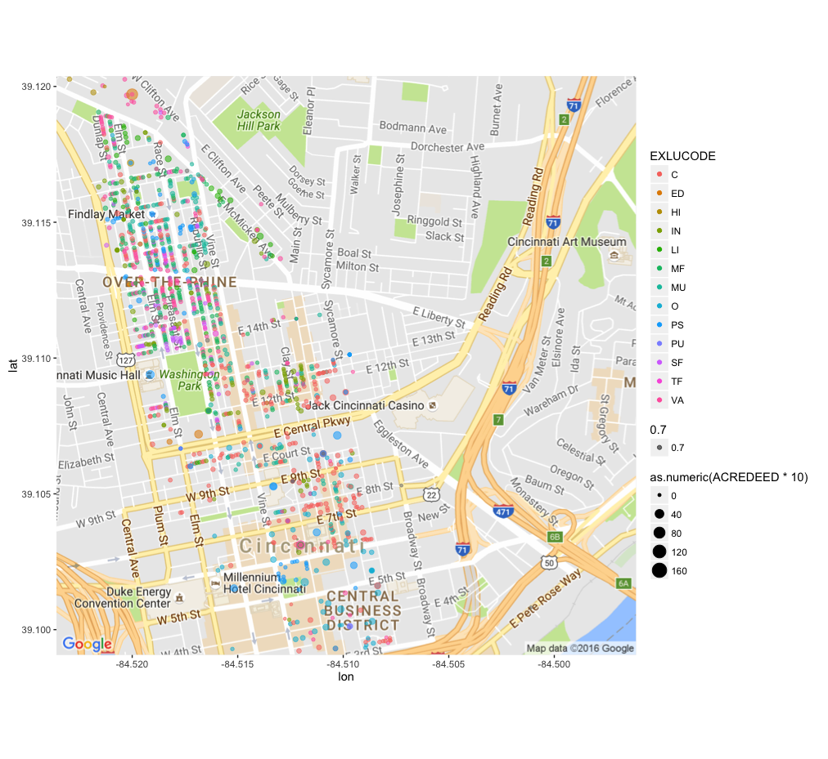

Figure 2: Scatterplot CORE Buffer Zone

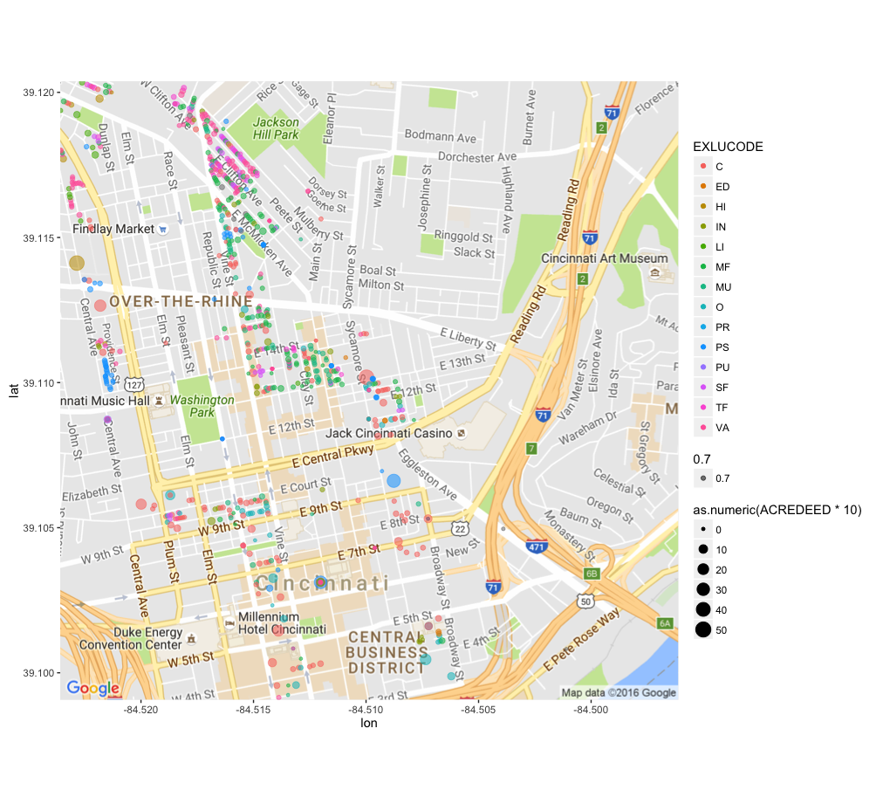

Figure 3: Scatterplot CENTER Buffer Zone

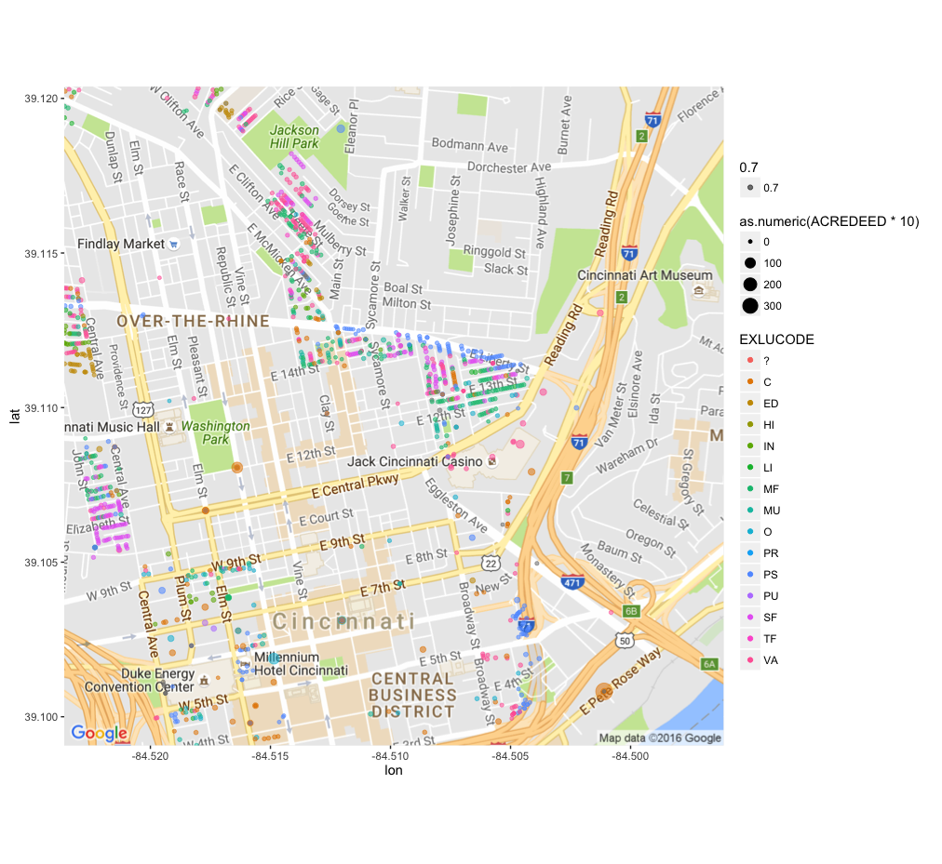

Figure 4: Scatterplot EDGE Buffer Zone

Next, referring to Figures 4, 5, and 6 below, within the Buffer Zones, we find that the distribution with respect to Existing Land Use is **not uniform**. The distribution is skewed towards Multi-family, Mixed Used, Vacant, Commercial and Public/Semi-public parcels. Additionally, there are too many parcels classified as vacant lots, which was confirmed by looking at GIS (Geographical information systems) data.

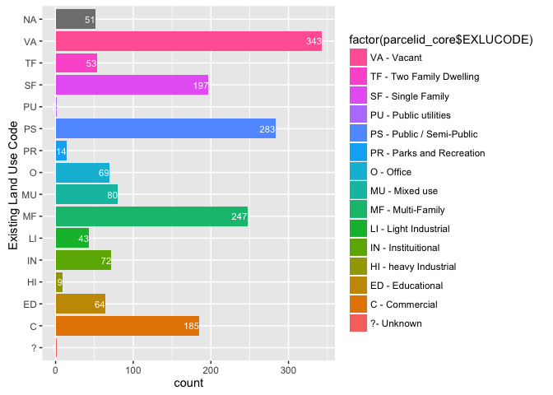

Figure 5. Histogram of parcels in CORE buffer zone.

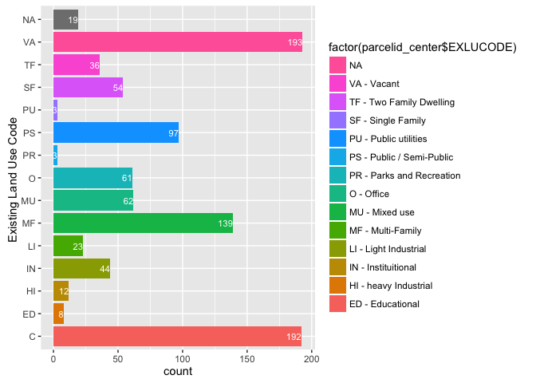

Figure 6. Histogram of parcels in CENTER buffer zone.

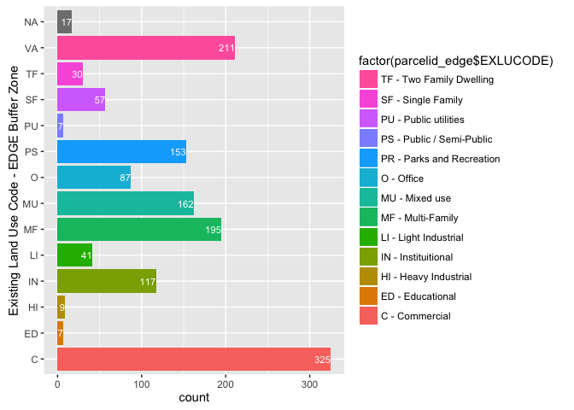

Figure 7. Histogram of parcels in the EDGE buffer zone

## Methodology

By creating a 2-D Kernel Density plot, we find the areas of high Market Land Value to be centered on the Buffer Zone. There **is an unanticipated high-distribution in the center of the Downtown** in all the three plots. This is indicative of either **a problematic geocoding or the street addresses in the data are not correct**. In the scatterplot, Figure 2, Figure 3 and Figure 4, this problem is masked because the points are over-lapping each other in a single point in the center of the downtown. However, a 2-D Kernel Density Map reveals an unusually high concentration of observations in areas **not expected** to be in the CENTER and EDGE buffer zones.

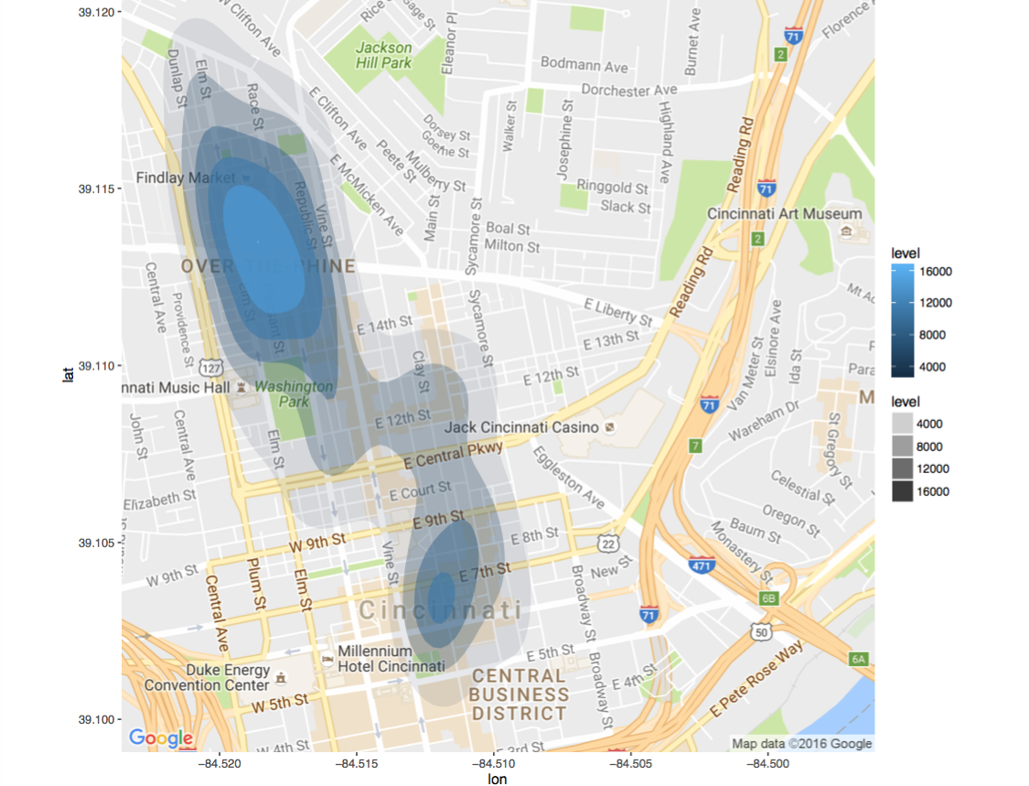

Figure 8: 2-D Kernel Density plot of CORE

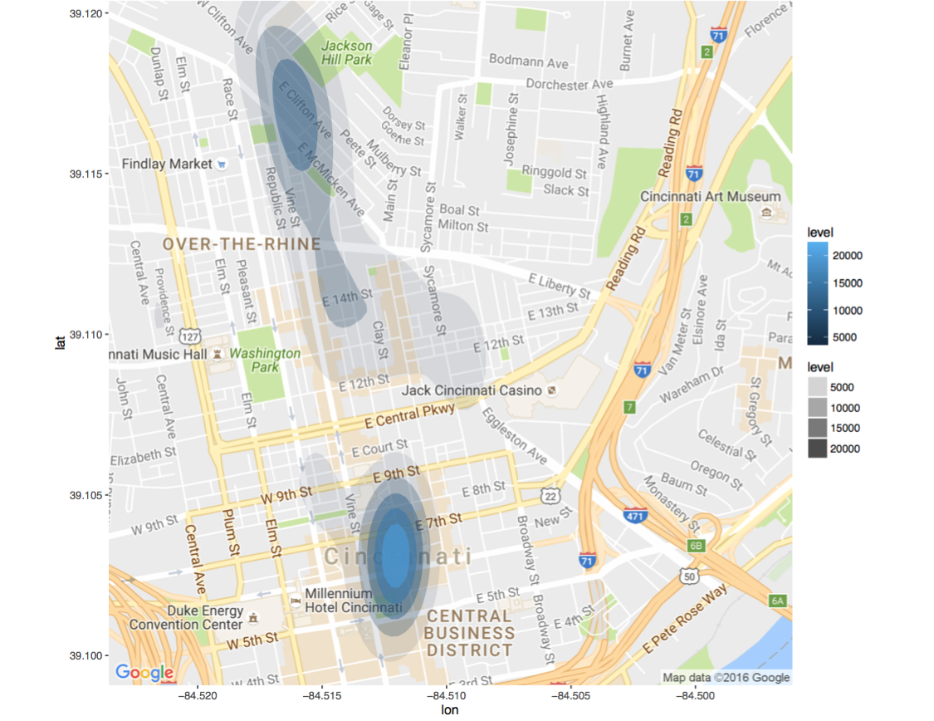

Figure 9: 2-D Kernel Density plot of CENTER: High density of observations near Central Business District is not expected

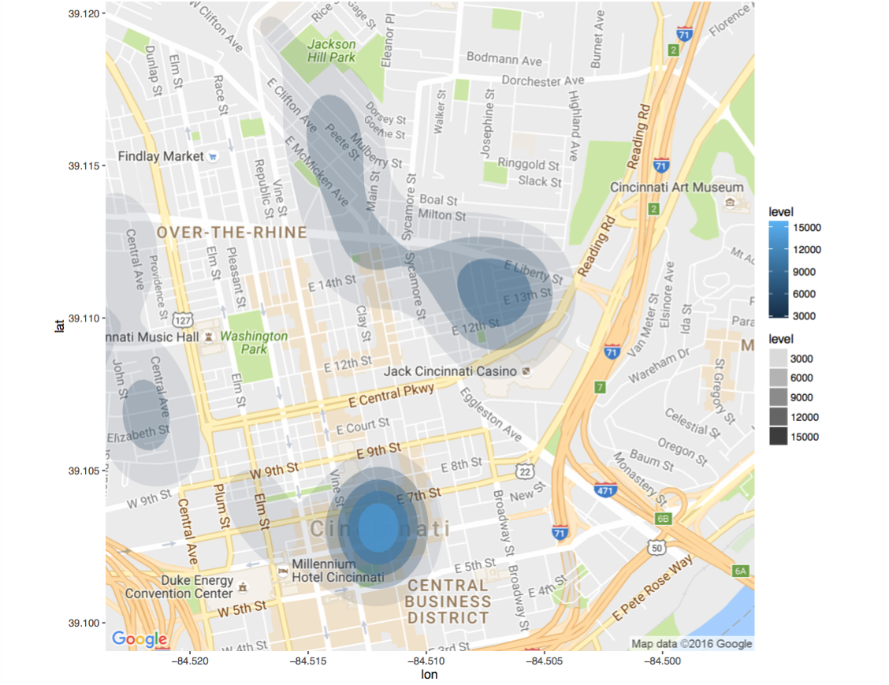

Figure 10: 2D Kernel Density plots of EDGE: High density of observations near Central Business District is not expected

The data sets were analyzed further with staff at CAGIS, and a cleaner data set was obtained. In the clean data set, we observe the distribution of observations contained within the CORE, CENTER and EDGE buffer zones.

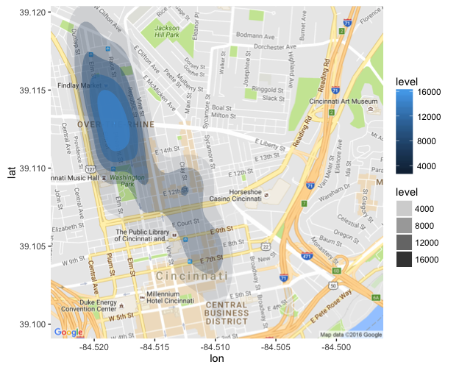

Figure 11: 2-D Kernel Density plot of the CORE parcels : AFTER – Clean Dataset provided by CAGIS

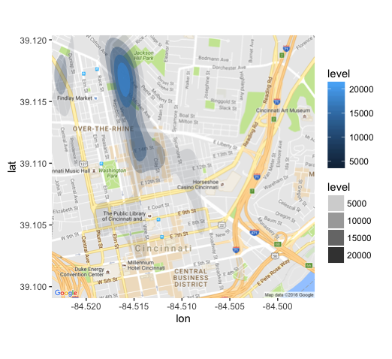

Figure 12: 2-D Kernel Density plot of the CENTER parcels: AFTER - Clean data provided by CAGIS - Central Business District are no longer there

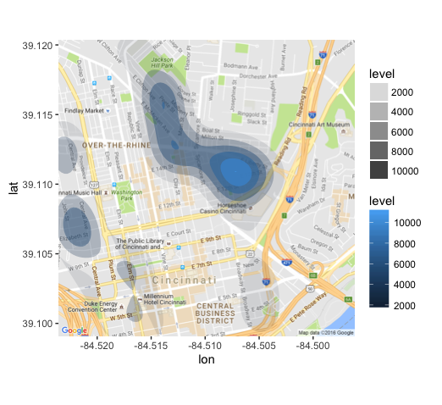

Figure 13: 2-D Kernel Density plots of the EDGE : After data was cleaned, observations are in line with expectations

## Conclusion (Data Exploration)

* 3 .csv files, one each for CORE, CENTER and EDGE buffer zone were analyzed.
* When loaded, the data frame dimensions were 1713x8, 946x8 and 1418x8 respectively.
* Top 5 Land Use in each buffer zone were: Commercial, Multi-Family, Mixed Use, Semi-Public and Vacant
  + Examples of Vacant lots were Parking lots, which is to be expected near Commercial centers.
* Parcels with zero Annual Taxes value were analyzed further. They correspond to one of the several parcels owned by a single owner. The taxes are assessed on all the parcels and aggregated only on one parcel for billing convenience. The other parcels are therefore marked zero.
* Density map indicated that some geocoded co-ordinates are not spatially situated in the buffer zones as expected.
  + For example, in Figures 8 and 9, there is a high density of observations Near the Central Business District, which seem to be present in all 3 buffer zone.
  + Some of these observations do not have complete addresses for Google Maps Geocoding API to provide accurate longitude and latitude co-ordinates.
* Further analysis of the data set with the client, CAGIS, indicated that condominium parcels are also not correctly treated in the data set provided.
* Finally, a more accurate data-set was requested:
  + Figures 10, 11, and 12 illustrate a better distribution of the parcels in the expected buffer zones.
  + In particular, the high density of observations near the Central Business District in Figures 7, 8 and 9, prior to clean up is no longer observed.
  + This paves way for sub-setting data for Forecast Analysis (Part II).
  + Instead of using Google Maps geocoding, longitude and latitude co-ordinates were obtained from CAGIS directly.

# **Part II: Prediction of Total Market Value of Parcels**

## Data and Sources

**The sources of data** were Cincinnati Area Geographic Information Systems (CAGIS) and the Hamilton County Auditor Office, Cincinnati, OH.

**Confidentiality of data:** Data is considered to be **Open Data** available to general public for use. Data is real and not from any competition or academic study. Further, permission was obtained to be able to post the files on github for the purpose of this study.

**Assessors Tax Information 2007-2015: The Hamilton County Auditor Office,Cincinnati, OH** provided data for 9 years in Fixed Width Format in 9 files.

* taxinfo2007.txt
* taxinfo2008.txt
* taxinfo2009.txt
* taxinfo2010.txt
* taxinfo2011.txt
* taxinfo2012.txt
* taxinfo2013.txt
* taxinfo2014.txt
* taxinfo2015.txt

| **Column Name** | **Example Data** | **Description** |
| --- | --- | --- |
| **PARCEL_ID** | 10001000100 | Unique id for a parcel |
|  |  |  |
| **LOC_STREET** |  | Location e.g. for 2327 Sussex Ave., Cincinnati Oh |
| **LOC_HOUSE_NO** | 2327 |
| **LOC_ST_DESC** | SUSSEX |
| **LOC_ST_IND** | AV |
| **LOC_ST_DIR** |  |
| **VALID_SALE** | Y | Yes or No |
| **NUM_PARCEL** | 3 | Number of Parcels |
| **MKT_LAND_VAL** | 23000 | Value of the Land |
| **MKT_IMPR_VAL** | 140570 | Market value of the Land |
| **MKT_TOTAL** | 163570 | Mkt. Total Val |
| **ACRES** | 0.246 | Acreage of the building |
| **SALE_AMOUNT** | 116000 | Sale Amount |
| **SALE_DATE** | 20121129 | Sale date in YYYYMMDD format |
| **NEW CONSTR** | N | Newly constructed building |
| **ANNUAL_TAXES** | 3693.14 | Annual Taxes Assessed |
| **TAXES_PAID** | 3693.14 | Annual Taxes Paid |
| **DELQ_TAXES** | 6088.56 | Delinquent taxes |
| **FORECL_FLAG** | Y | Tax Foreclosure Flag |

**Table 2: Features selected from Property Tax Information from years 2007 – 2015**

## Extraction, Transformation, and Loading of Data

**Property Tax information 2007-2015**: The original datasets were provided in fixed width format. An R script converted it to .csv file. The problem here was **each** of the groups of years 2007, 2008 and 2009-2014 and 2015 had different column widths. The field width was clearly documented. There are about 290,000 observations for each year. The final loaded data frame dimensions were 2,190,994 observations x 13

## Feature Selection

From the tax-information of the data set a few features have been identified for selection. These selections are indicative of economic growth – Market Value, Assessed taxes, Revenue from Taxes paid, Sales data, Foreclosure Data and New Construction Flag

| Sl | VARIABLE | Description |
| --- | --- | --- |
| 1 | **PARCELID** | *A Unique identifier of the parcel* |
| 2 | **LOC_STREET** | *Address for plotting on ggplot or other package to identify spatial correlation* |
| 3 | **LOC_HOUSE_NO** | *Street Address Location + Latitude and Longitude* |
| 4 | **LOC_ST_DESC** |
| 5 | **LOC_ST_IND** |
| 6 | **LOC_ST_DIR** |
| 7 | **cent_long** |
| 8 | **cent_lat** |
| 9 | **EXLU_CODE** | *Existing Land Use code* |
| 10 | **MKT_LAND_VAL** | *Market Value of land, Improvements, and Total* |
| 12 | **MKT_IMPR_VAL** |
| 13 | **MKT_TOTAL** |
| 14 | **ANNUAL_TAXES** | *Net Prop Tax revenue: Annual Taxes assessed, Taxes actually Paid, Delinquent Taxes and Tax Foreclosure* |
| 15 | **TAXES_PAID** |
| 16 | **DELQ_TAXES** |
| 17 | **FORECL_FLAG** |
| 18 | **ACRE** | *Acreage to compute Property Value / sq. ft.* |
| 19 | **SALE_AMT** | *Sales data of Property: Amount, Sale Date, New Construction* |
| 20 | **VALID_SALE** |
| 21 | **SALE_DATE** |
| 22 | **NEW_CONSTR** |

**Table 3: There are several features available in the data set for years 2007-2015. The features in the table above have been selected and are indicators of Market value of the parcel, Annual taxes, Acre-age, Sales Data. These are representative of the net economic effect.**

|  |  |  |  |  |  |  |  |  |  |
| --- | --- | --- | --- | --- | --- | --- | --- | --- | --- |
| **PARCELID** | **2007** | **2008** | **2009** | **2010** | **2011** | **2012** | **2013** | **2014** | **2015** |
|  |  |  |  |  |  |  |  |  |  |
| Over 290,000 observations/year | | | | | | | | | |
|  |  |  |  |  |  |  |  |  |  |
|  |  |  |  |  |  |  |  |  |  |

**Table 4: Parcel id uniquely identifies an observation. Each year from 2007-2015 has a subset of features shown in Table 10. This data is not tidy data and will need to be transformed using tidyr into Table 12.**

During the course of the investigation, it was decided to limit the scope of the study to MKT_TOTAL_VAL, which stands for Total Market Value. It is the assessed value of a parcel including the land and the improvements (buildings, structures on the land). This decision to limit the scope came about because of time, resources and the effort required to clean the data.

|  |  |  |
| --- | --- | --- |
| YEAR | PARCEL_ID | MKT_TOTAL_VAL |
| 2007 | 0010001000100 | 160,000 |
|  | … |  |
|  | … |  |
| 2007 | … |  |
| 2008 | 0010001000100 | 160,000 |
|  | … |  |
|  |  |  |
| 2008 |  |  |
| 2015 | 0010001000100 | 163,570 |
|  |  |  |
|  |  |  |
| 2015 |  |  |

**Table 5: The final data from df_MKT_TOTAL_VAL 2,190,994 observations of 3 variables – YEAR, PARCEL_ID and MKT_TOTAL_VAL**

## Data and Analyses

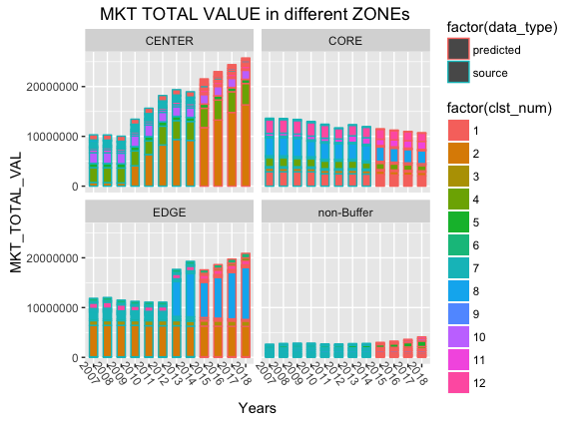

Figure 14: comparison of MKT_TOTAL_VAL in dollars in different zones. For comparison, 1224 parcels were chosen randomly from over 290,000 parcels in the Hamilton County. These were compared against CORE, CENTER, and EDGE buffer zones. Source data for years 2007-2014 (histograms outlined in teal color) along with forecast data for years 2015-2018 (histograms outlined in red) is displayed in the histogram.

* Parcels in Buffer zones have had large MKT_TOTAL_VAL compared to the non-Buffer Zone.
* The CENTER zones exhibit largest increase in MKT_TOTAL_VAL.
* Then it is closely followed by the EDGE zone.
* The changes in the CORE zone is the least.
* It is possible that the demand on properties situated in the CENTER and EDGE zones, is dictated by just-the-right-proximity to the streetcar. Too close seems less desirable.

**CENTER ZONE vs. EDGE ZONE**

# 

Figure 15:Comparison of CENTER and EDGE zones

A comparison between CENTER and EDGE zones, illustrated in the histogram in Figure 15, (above) shows, that the forecast for MKT_TOTAL_VAL for the years 2015-2018 of the CENTER zone is more than the EDGE zones for the years 2016-2018. Within the CENTER zone, the properties within cluster 2 show most significant growth in MKT_TOTAL_VAL.

**CORE ZONE vs. NON-BUFFER ZONE**

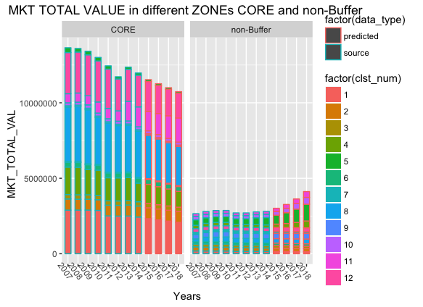

Figure 16: Comparison of CORE and non-Buffer zones

The non-Buffer zone trend shows an overall positive MKT_TOTAL_VAL trend even though it showed periods of declining trends in some of the years viz.,2010-2013. The prediction models a forecast of increasing values for the years 2015-2018. The CORE buffer zone model predicts a decline in MKT_TOTAL_VAL. Within the CORE zone, parcels in Cluster 1 show the greatest declining trend.

## Methodology

The following flow chart illustrates an overview of the methodology

## ETL Methodology

**Step 1:** Nine data frames, representing9 years (2007-2015) of data were bound into a single data frame df_all. The original data included 13 predictors X 2,191,115 observations.

**Step 2:** To scope down the project, it was decided to focus on MKT_TOTAL_VAL predictor. The annual tax collected is a function of the MKT_TOTAL_VAL. It represents the land value and the value of the improvements (i.e. buildings on the land).

**Step 3:** To create a time series object, the data-frame df_all, had to be **re-shaped** into a wide format, entries with NA removed, and duplicate entries removed. Further, only data with 8 complete years (2007-2014) of data was used for study (detailed explanations in the Problems section). The final data frame was a matrix of 8 observations X 241748 predictors. There were only 8 observations / parcel id as the assessment is done on an annual basis.

## Standardization

**Step4**: A **time series object** and analysis for every one of 241,748 parcel-ids **each with a frequency of 1 year** was not practical. So, as a next step it was decided to use a learning sample with a size of about 1224 parcels picked at random from a population of 241,748 parcels. 1224 was the mean sample size of the 3 buffer zones under study. This represents about 0.51699 % of the population size.

Using the **scale()** function, the MKT_TOTAL_VAL for each parcel-id was **standardized** (number of standard deviations away from the mean) in preparation for clustering of variables.

## Dimension Reduction

**Step 5: Clustering of variables** is useful for **dimension reduction**.

Clustering of variables is as a way to arrange variables into homogeneous clusters i.e. groups of variables which are strongly related to each other and thus bring the same information. In this study, parcels with similar MKT_TOTAL_VAL trends over 8 years, were clustered together. For each zone under study, using **ClustOfVar library**, an ascendant hierarchical clustering of **PARCEL_IDs** was performed using **hclustvar ()** function. The aggregation criterion is the decrease in homogeneity for the cluster being merged. The homogeneity of a cluster is the sum of the squared correlation between the variables and the center of the cluster, which is the first principal component of PCAmix.

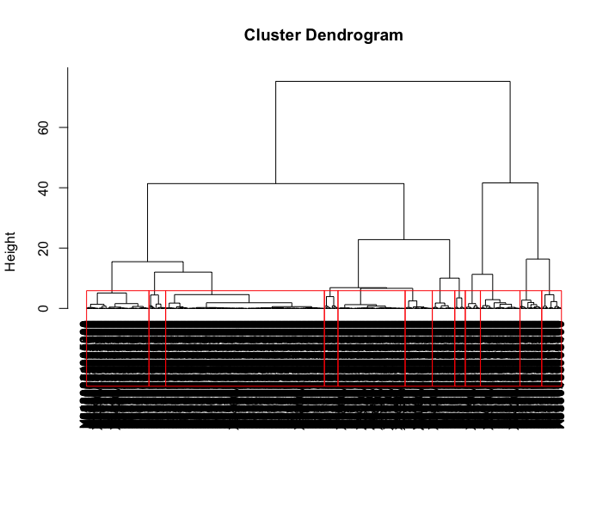

Figure 17: Dendogram of non-Buffer zone of 1224 sample parcel ids from the Hamilton County

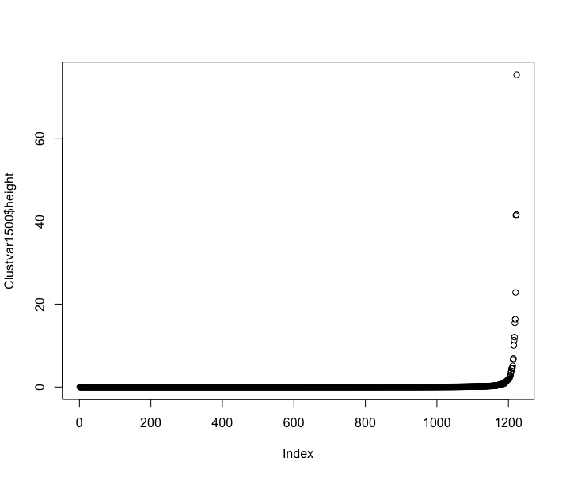

Figure 18: Based on intuition and the plot of height variable of the hclust object, a cluster of 12 seemed reasonable choice for further analyses

Based on the plot of the height variable of hclust variable as well as intuitions, cluster size of

k = 12 was chosen.

## Forecast Model Development and Selection

**Step 6: Polynomial regression**

Polynomial regression extends the linear model by adding extra predictors obtained by raising the predictors to a power. This approach provides a simple way to provide a non- linear fit to data. For each of the clusters, cluster 1 through cluster 12, a polynomial regression model of the order - 1(linear), 2(quadratic), 3(cubic), 4 and 5 was created. The **training set** for each cluster was created for each polynomial order using the years 2007-2012. The **test set** was 2013-2014.

**Step 7: Model Selection:**

For each cluster and for each polynomial order, the Mean Absolute Percentage Error (MAPE) was computed for the test set. Variable **y** is actual value, and the variable **yhat** is the predicted value of the model.

**Step 8: Visualize the Mean Absolute Percentage Error (MAPE**): For each zone, the MAPE was calculated and visualized on a plot. With a user-defined function call, the actual vs. predicted MKT_TOTAL_VAL for each cluster and for each polynomial order was plotted. This plot reveals, that models with higher order polynomials have higher error on the test-data. The linear and quadratic order of polynomials is sufficient to describe most clusters, and at the most a cubic equation.

EDGE MAPE Visualization and Tabulation

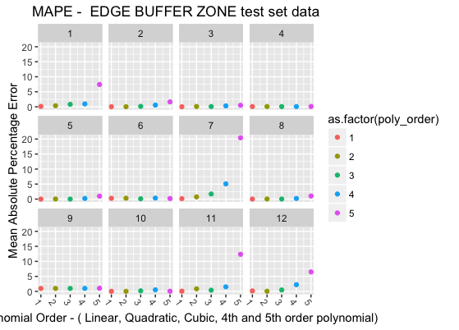

Figure 19. Mean Absolute Percentage error for EDGE buffer zone . Each panel in the facet represents the MAPE for that cluster. X- axis is order of polynomial. The Y-axis is the Mean absolute Percentage error. It is observed, that higher the polynomial order of the model, higher the error. As an example, for cluster 10, a polynomial of order 2 has the minimum MAPE and the predictive model od order 2 is chosen from out of 5 models.

| **ZONE** | **mape** | **poly_order** | **cluster** |
| --- | --- | --- | --- |
| **EDGE** | **0.130266228** | **1** | **1** |
| EDGE | 0.352409434 | 2 | 1 |
| EDGE | 0.805962756 | 3 | 1 |
| EDGE | 0.961419082 | 4 | 1 |
| EDGE | 7.430035127 | 5 | 1 |
| EDGE | 0.03599647 | 1 | 2 |
| EDGE | 0.042011492 | 2 | 2 |
| EDGE | 0.144317939 | 3 | 2 |
| EDGE | 0.562098914 | 4 | 2 |
| EDGE | 1.63911057 | 5 | 2 |
| EDGE | 0.016651428 | 1 | 3 |
| EDGE | 0.083331485 | 3 | 3 |
| EDGE | 0.104229433 | 2 | 3 |
| EDGE | 0.302099441 | 4 | 3 |
| EDGE | 0.489966503 | 5 | 3 |
| EDGE | 0.073921931 | 3 | 4 |
| EDGE | 0.079867675 | 4 | 4 |
| EDGE | 0.082291995 | 1 | 4 |
| EDGE | 0.101789255 | 2 | 4 |
| EDGE | 0.105465291 | 5 | 4 |
| EDGE | 0.003645521 | 1 | 5 |
| EDGE | 0.009309043 | 3 | 5 |
| EDGE | 0.033841576 | 2 | 5 |
| EDGE | 0.223668396 | 4 | 5 |
| EDGE | 0.983326975 | 5 | 5 |
| EDGE | 0.102201592 | 3 | 6 |
| EDGE | 0.18812537 | 5 | 6 |
| EDGE | 0.260604994 | 1 | 6 |
| EDGE | 0.285571349 | 2 | 6 |
| EDGE | 0.332964935 | 4 | 6 |
| EDGE | 0.142685244 | 1 | 7 |
| EDGE | 0.742903157 | 2 | 7 |
| EDGE | 1.698010483 | 3 | 7 |
| EDGE | 5.072946484 | 4 | 7 |
| EDGE | 20.41624547 | 5 | 7 |
| EDGE | 0.008089368 | 1 | 8 |
| EDGE | 0.019598125 | 3 | 8 |
| EDGE | 0.03729133 | 2 | 8 |
| EDGE | 0.208665237 | 4 | 8 |
| EDGE | 1.025348029 | 5 | 8 |
| EDGE | 0.976711297 | 1 | 9 |
| EDGE | 0.979081715 | 2 | 9 |
| EDGE | 0.983982979 | 3 | 9 |
| EDGE | 0.997468716 | 4 | 9 |
| EDGE | 1.047297127 | 5 | 9 |
| EDGE | 0.032591925 | 1 | 10 |
| EDGE | 0.032988102 | 2 | 10 |
| EDGE | 0.065901839 | 5 | 10 |
| EDGE | 0.179803786 | 3 | 10 |
| EDGE | 0.514891729 | 4 | 10 |
| EDGE | 0.082420641 | 1 | 11 |
| EDGE | 0.402413533 | 3 | 11 |
| EDGE | 0.854559938 | 2 | 11 |
| EDGE | 1.512671045 | 4 | 11 |
| EDGE | 12.35432366 | 5 | 11 |
| EDGE | 0.055122975 | 2 | 12 |
| EDGE | 0.153463021 | 1 | 12 |
| EDGE | 0.47816778 | 3 | 12 |
| EDGE | 2.232913354 | 4 | 12 |
| EDGE | 6.487499005 | 5 | 12 |

*Table 6: The Table above depicts the MAPE for different clusters in the EDGE buffer zone. All the rows marked in blue font, represent the best model out of 5 polynomial order. As an example, For Cluster 12, polynomial order of 2 is selected as the its MAPE – 0.055122975 is the least amongst all the models.*

*CENTER ZONE MAPE*

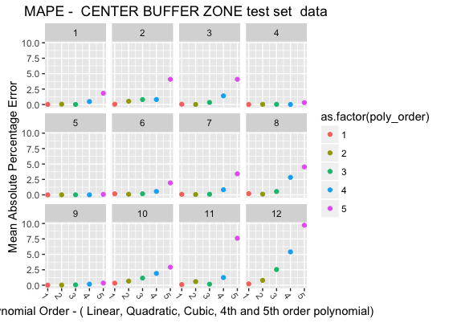

Figure 20 : For the CENTER buffer zone, the mean absolute percentage error was plotted against the polynomial order of the prediction model. Again, the higher order models don't provide and advantage. A polynomial order of 3 provides a predictive model with MAPE below 3%. As an example, for cluster 2, a linear model has the minimum MAPE and the predictive model of order 1 is chosen from out of 5 models.

| **ZONE** | **mape** | **poly_order** | **cluster** |
| --- | --- | --- | --- |
| CENTER | 0.016343028 | 3 | 1 |
| CENTER | 0.021384836 | 1 | 1 |
| CENTER | 0.056176972 | 2 | 1 |
| CENTER | 0.477860303 | 4 | 1 |
| CENTER | 1.827638765 | 5 | 1 |
| CENTER | 0.048927778 | 1 | 2 |
| CENTER | 0.527791297 | 2 | 2 |
| CENTER | 0.806746254 | 3 | 2 |
| CENTER | 0.815373041 | 4 | 2 |
| CENTER | 4.089342697 | 5 | 2 |
| CENTER | 0.010773457 | 2 | 3 |
| CENTER | 0.056878019 | 1 | 3 |
| CENTER | 0.3333754 | 3 | 3 |
| CENTER | 1.405540418 | 4 | 3 |
| CENTER | 4.086352471 | 5 | 3 |
| CENTER | 0.00843079 | 1 | 4 |
| CENTER | 0.0100403 | 4 | 4 |
| CENTER | 0.029542063 | 2 | 4 |
| CENTER | 0.03338133 | 3 | 4 |
| CENTER | 0.305243261 | 5 | 4 |
| CENTER | 0.001235563 | 1 | 5 |
| CENTER | 0.004612875 | 4 | 5 |
| CENTER | 0.008211826 | 3 | 5 |
| CENTER | 0.009270585 | 2 | 5 |
| CENTER | 0.081217571 | 5 | 5 |
| CENTER | 0.10045817 | 2 | 6 |
| CENTER | 0.167168318 | 1 | 6 |
| CENTER | 0.17211478 | 3 | 6 |
| CENTER | 0.555049657 | 4 | 6 |
| CENTER | 1.941119623 | 5 | 6 |
| CENTER | 0.054077775 | 2 | 7 |
| CENTER | 0.092163761 | 1 | 7 |
| CENTER | 0.099078205 | 3 | 7 |
| CENTER | 0.832376163 | 4 | 7 |
| CENTER | 3.410496159 | 5 | 7 |
| CENTER | 0.111232247 | 2 | 8 |
| CENTER | 0.193387079 | 1 | 8 |
| CENTER | 0.545576374 | 3 | 8 |
| CENTER | 2.831905561 | 4 | 8 |
| CENTER | 4.532482291 | 5 | 8 |
| CENTER | 0.01659657 | 1 | 9 |
| CENTER | 0.031085984 | 2 | 9 |
| CENTER | 0.058165354 | 3 | 9 |
| CENTER | 0.172687635 | 4 | 9 |
| CENTER | 0.345927555 | 5 | 9 |
| CENTER | 0.329115079 | 1 | 10 |
| CENTER | 0.665319571 | 2 | 10 |
| CENTER | 1.147097496 | 3 | 10 |
| CENTER | 1.903876286 | 4 | 10 |
| CENTER | 2.92404141 | 5 | 10 |
| CENTER | 0.101459588 | 1 | 11 |
| CENTER | 0.168604557 | 3 | 11 |
| CENTER | 0.584824152 | 2 | 11 |
| CENTER | 1.242655976 | 4 | 11 |
| CENTER | 7.607897508 | 5 | 11 |
| CENTER | 0.209887178 | 1 | 12 |
| CENTER | 0.78164799 | 2 | 12 |
| CENTER | 2.544333123 | 3 | 12 |
| CENTER | 5.398389057 | 4 | 12 |
| CENTER | 9.719800356 | 5 | 12 |

Table 7: The Table above depicts the MAPE for different clusters in the CENTER buffer zone. As an example, For Cluster 11, polynomial order of 1 is selected as its MAPE – 0.0101459588 is the least amongst all the models

CORE ZONE MAPE

Visualization

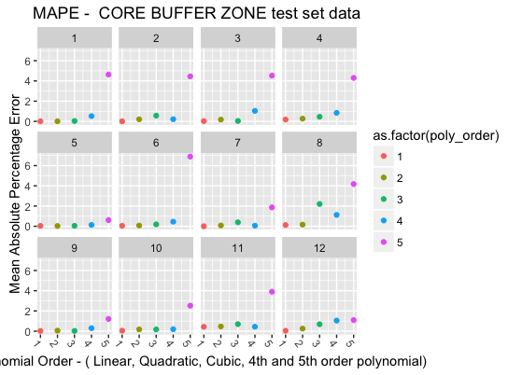

Figure 21 : For the CORE buffer zone, the mean absolute percentage error was plotted against the polynomial order of the prediction model. Again, the higher-order models don't provide any advantage. A polynomial order of 3 provides a predictive model with MAPE below 3%. As an example, for cluster 2, a polynomial of order 4 has the minimum MAPE and the predictive model of order 4 is chosen from out of 5 models

Tabulation

| **ZONE** | **mape** | **poly_order** | **cluster** |
| --- | --- | --- | --- |
| CORE | 0.004872816 | 1 | 1 |
| CORE | 0.008516562 | 2 | 1 |
| CORE | 0.039673932 | 3 | 1 |
| CORE | 0.522016619 | 4 | 1 |
| CORE | 4.632403954 | 5 | 1 |
| CORE | 0.005290909 | 1 | 2 |
| CORE | 0.206713115 | 2 | 2 |
| CORE | 0.216460808 | 4 | 2 |
| CORE | 0.567874555 | 3 | 2 |
| CORE | 4.450788902 | 5 | 2 |
| CORE | 0.029460522 | 1 | 3 |
| CORE | 0.04174543 | 3 | 3 |
| CORE | 0.174133769 | 2 | 3 |
| CORE | 1.03867621 | 4 | 3 |
| CORE | 4.524604578 | 5 | 3 |
| CORE | 0.181560082 | 1 | 4 |
| CORE | 0.269052816 | 2 | 4 |
| CORE | 0.457535536 | 3 | 4 |
| CORE | 0.842600115 | 4 | 4 |
| CORE | 4.297242856 | 5 | 4 |
| CORE | 0.028808304 | 2 | 5 |
| CORE | 0.037541207 | 1 | 5 |
| CORE | 0.047344398 | 3 | 5 |
| CORE | 0.130659526 | 4 | 5 |
| CORE | 0.609662795 | 5 | 5 |
| CORE | 0.04827739 | 1 | 6 |
| CORE | 0.075161022 | 2 | 6 |
| CORE | 0.192299896 | 3 | 6 |
| CORE | 0.454564776 | 4 | 6 |
| CORE | 6.89160822 | 5 | 6 |
| CORE | 0.005970698 | 1 | 7 |
| CORE | 0.058469101 | 4 | 7 |
| CORE | 0.079588256 | 2 | 7 |
| CORE | 0.391709144 | 3 | 7 |
| CORE | 1.869740956 | 5 | 7 |
| CORE | 0.120563564 | 1 | 8 |
| CORE | 0.166185308 | 2 | 8 |
| CORE | 1.124275032 | 4 | 8 |
| CORE | 2.203831865 | 3 | 8 |
| CORE | 4.172720001 | 5 | 8 |
| CORE | 0.02362266 | 1 | 9 |
| CORE | 0.026249237 | 3 | 9 |
| CORE | 0.050050992 | 2 | 9 |
| CORE | 0.294979312 | 4 | 9 |
| CORE | 1.207071956 | 5 | 9 |
| CORE | 0.047302574 | 1 | 10 |
| CORE | 0.169080039 | 3 | 10 |
| CORE | 0.172359721 | 2 | 10 |
| CORE | 0.191077965 | 4 | 10 |
| CORE | 2.519043797 | 5 | 10 |
| CORE | 0.429630049 | 1 | 11 |
| CORE | 0.439375707 | 4 | 11 |
| CORE | 0.465385367 | 2 | 11 |
| CORE | 0.697725879 | 3 | 11 |
| CORE | 3.902736665 | 5 | 11 |
| CORE | 0.041833768 | 1 | 12 |
| CORE | 0.252656675 | 2 | 12 |
| CORE | 0.686313095 | 3 | 12 |
| CORE | 1.047413735 | 4 | 12 |
| CORE | 1.090634266 | 5 | 12 |

*Table 8:. The table above depicts the MAPE for different clusters in the CORE buffer zone. As an example, For Cluster 12, polynomial order of 1 is selected as its MAPE – 0.041833768 is the least amongst all the models.*

## Prediction

**Step 8**: Next, we call a user-defined function non_linear_regression_model (). The pseudo-code is as follows:

* For each buffer zone in the list {CORE, CENTER and EDGE}
  + For each polynomial order in the list {linear, quadratic, cubic, 4th order and 5th order}
    - For each Cluster in a buffer zone
      * Create a time series object on the row means (years 2007-2014) and create a non-linear regression model using
      * **df_mkt_val3 <-lm (ts_train_cl_num [1:8] ~ poly(Time,poly_order))**
      * Return a data frame by binding the source MKT_TOTAL_VAL for years 2007-2014 and Predicted MKT_TOTAL_VAL for years 2015-2018
      * Visualize the plot

## Visualization of Results

|  |  |  |
| --- | --- | --- |
| CORE |  |  |
| CENTER |  |  |
| EDGE |  |  |

Figure 22: Visualization of MKT_TOTAL_VALUE of the three buffers. X axis in Years ( 2007-2014 – source years , 2015-2018 predicted years). Y-axis represents MKT_TOTAL_VAL in dollars. First Column represents results of linear regression model; the 2nd column represents quadratic polynomial regression. Each sub-panel in the facet depicts a histogram for the cluster number. TOP: Cluster 1 dominates the downward trend in MKT_TOTAL_VAL. MIDDLE: Clusters 2 dominate increasing trends. Cluster 8 dominates the rising trend .



Figure 23: Final comparison of all MKT_TOTAL_VAL. Source data for years 2007-2014 is depicted in histograms with a teal- colored border. The predicted data for years 2015-2018 is depicted in histograms with red-colored border. Of the 4 zones, the CENTER ZONE shows maximum appreciation on value. Surprisingly, CORE zone with closest proximity exhibits declining values. EDGE Zone exhibits increasing market value but is less than the CENTER zone. Finally, the non-buffer zone which is a sample of parcels from the rest of the Hamilton county, shows increasing trends but at much lower rate than the buffer-zone.

## Tabulation of Findings

The following Table 9 supports the results of the study as a numerical summary of the findings.

* **zone** - Column 1 is the zone under study *viz*. CORE,CENTER, EDGE, and non-Buffer zones.
* **clst_num** - Within each zone, we had performed clustering and the column 2 , clst_num is the cluster within the zone.
* **date** - date column depicts the year.
* **data_type -** refers to source data or predicted data.
* **mean_mkt_val** - For each cluster, we had performed row means. Mean_mkt_val represents the mean of all the MKT_TOTAL_VAL for each parcel_id the cluster.
* **num_parcel_ids** - is the number of parcels within the cluster.
* **mkt_total** - is **mean_mkt_val** X **num_parcel_ids**.
* **min_mape_poly** - is the polynomial order of the model with minimum MAPE
* **min_mape** – is the minimum MAPE

Table 9: Tabulation of the Source Data 2007-2014 and Predicted data for years 2015-2018

| **zone** | **clst_num** | **date** | **data_type** | **mean_mkt_val** | **num_parcel_ids** | **mkt_total** | **min_mape_poly** | **min_mape** |
| --- | --- | --- | --- | --- | --- | --- | --- | --- |
| CENTER | 1 | 2007 | source | 1031284.534 | 247 | 254727280 | 3 | 0.01634303 |
| 2008 | source | 1020694.413 | 252111520 |
| 2009 | source | 1020597.935 | 252087690 |
| 2010 | source | 1020597.935 | 252087690 |
| 2011 | source | 1082296.964 | 267327350 |
| 2012 | source | 1082149.352 | 267290890 |
| 2013 | source | 1082128.664 | 267285780 |
| 2014 | source | 1069018.623 | 264047600 |
| 2015 | predicted | 1010939.02 | 249701937.9 |
| 2016 | predicted | 909783.691 | 224716571.7 |
| 2017 | predicted | 753500.9977 | 186114746.4 |
| 2018 | predicted | 532106.2484 | 131430243.4 |
| CENTER | 2 | 2007 | source | 735434.6154 | 26 | 19121300 | 1 | 0.04892778 |
| 2008 | source | 705013.0769 | 18330340 |
| 2009 | source | 641629.2308 | 16682360 |
| 2010 | source | 4087940.769 | 106286460 |
| 2011 | source | 6351003.462 | 165126090 |
| 2012 | source | 8262269.231 | 214819000 |
| 2013 | source | 9376237.308 | 243782170 |
| 2014 | source | 9198077.692 | 239150020 |
| 2015 | predicted | 11761822.39 | 305807382.1 |
| 2016 | predicted | 13282293.88 | 345339641 |
| 2017 | predicted | 14802765.38 | 384871899.8 |
| 2018 | predicted | 16323236.87 | 424404158.6 |
| CENTER | 3 | 2007 | source | 149850.4348 | 46 | 6893120 | 2 | 0.01077346 |
| 2008 | source | 198189.5652 | 9116720 |
| 2009 | source | 209098.6957 | 9618540 |
| 2010 | source | 177585.6522 | 8168940 |
| 2011 | source | 161628.0435 | 7434890 |
| 2012 | source | 161628.0435 | 7434890 |
| 2013 | source | 161607.6087 | 7433950 |
| 2014 | source | 160826.9565 | 7398040 |
| 2015 | predicted | 133946.875 | 6161556.25 |
| 2016 | predicted | 114506.4868 | 5267298.393 |
| 2017 | predicted | 91807.64881 | 4223151.845 |
| 2018 | predicted | 65850.36102 | 3029116.607 |
| CENTER | 4 | 2007 | source | 2987850 | 14 | 41829900 | 1 | 0.00843079 |
| 2008 | source | 2996524.286 | 41951340 |
| 2009 | source | 2996524.286 | 41951340 |
| 2010 | source | 2996524.286 | 41951340 |
| 2011 | source | 2738612.143 | 38340570 |
| 2012 | source | 3789140 | 53047960 |
| 2013 | source | 3789140 | 53047960 |
| 2014 | source | 3788982.143 | 53045750 |
| 2015 | predicted | 3886712.423 | 54413973.93 |
| 2016 | predicted | 4025890.264 | 56362463.69 |
| 2017 | predicted | 4165068.104 | 58310953.45 |
| 2018 | predicted | 4304245.944 | 60259443.21 |
| CENTER | 5 | 2007 | source | 836345.4348 | 46 | 38471890 | 1 | 0.00123556 |
| 2008 | source | 839603.6957 | 38621770 |
| 2009 | source | 839603.6957 | 38621770 |
| 2010 | source | 839603.6957 | 38621770 |
| 2011 | source | 836827.6087 | 38494070 |
| 2012 | source | 836827.6087 | 38494070 |
| 2013 | source | 836827.6087 | 38494070 |
| 2014 | source | 804486.087 | 37006360 |
| 2015 | predicted | 820479.9534 | 37742077.86 |
| 2016 | predicted | 817527.5699 | 37606268.21 |
| 2017 | predicted | 814575.1863 | 37470458.57 |
| 2018 | predicted | 811622.8028 | 37334648.93 |
| CENTER | 6 | 2007 | source | 277924.1935 | 31 | 8615650 | 2 | 0.10045817 |
| 2008 | source | 278802.5806 | 8642880 |
| 2009 | source | 278802.5806 | 8642880 |
| 2010 | source | 278802.5806 | 8642880 |
| 2011 | source | 280430.9677 | 8693360 |
| 2012 | source | 277895.4839 | 8614760 |
| 2013 | source | 277895.4839 | 8614760 |
| 2014 | source | 281640.3226 | 8730850 |
| 2015 | predicted | 280775.9217 | 8704053.571 |
| 2016 | predicted | 281458.341 | 8725208.571 |
| 2017 | predicted | 282228.7097 | 8749090 |
| 2018 | predicted | 283087.0276 | 8775697.857 |
| CENTER | 7 | 2007 | source | 805675.625 | 48 | 38672430 | 2 | 0.05407778 |
| 2008 | source | 806418.125 | 38708070 |
| 2009 | source | 806418.125 | 38708070 |
| 2010 | source | 808501.4583 | 38808070 |
| 2011 | source | 742311.0417 | 35630930 |
| 2012 | source | 742367.0833 | 35633620 |
| 2013 | source | 742367.0833 | 35633620 |
| 2014 | source | 615970.7292 | 29566595 |
| 2015 | predicted | 576251.1365 | 27660054.55 |
| 2016 | predicted | 499976.4317 | 23998868.72 |
| 2017 | predicted | 412986.1502 | 19823335.21 |
| 2018 | predicted | 315280.292 | 15133454.02 |
| CENTER | 8 | 2007 | source | 367359.0476 | 21 | 7714540 | 2 | 0.11123225 |
| 2008 | source | 223589.0476 | 4695370 |
| 2009 | source | 223589.0476 | 4695370 |
| 2010 | source | 223589.0476 | 4695370 |
| 2011 | source | 222735.7143 | 4677450 |
| 2012 | source | 222735.7143 | 4677450 |
| 2013 | source | 222735.7143 | 4677450 |
| 2014 | source | 219206.6667 | 4603340 |
| 2015 | predicted | 272374.5238 | 5719865 |
| 2016 | predicted | 318370.7937 | 6685786.667 |
| 2017 | predicted | 376053.8095 | 7897130 |
| 2018 | predicted | 445423.5714 | 9353895 |
| CENTER | 9 | 2007 | source | 35131.25 | 16 | 562100 | 1 | 0.01659657 |
| 2008 | source | 34783.75 | 556540 |
| 2009 | source | 34783.75 | 556540 |
| 2010 | source | 34783.75 | 556540 |
| 2011 | source | 34981.875 | 559710 |
| 2012 | source | 34981.875 | 559710 |
| 2013 | source | 34981.875 | 559710 |
| 2014 | source | 34767.5 | 556280 |
| 2015 | predicted | 34858.57143 | 557737.1429 |
| 2016 | predicted | 34849.48661 | 557591.7857 |
| 2017 | predicted | 34840.40179 | 557446.4286 |
| 2018 | predicted | 34831.31696 | 557301.0714 |
| CENTER | 10 | 2007 | source | 2124588.889 | 9 | 19121300 | 1 | 0.32911508 |
| 2008 | source | 2124803.333 | 19123230 |
| 2009 | source | 2124347.778 | 19119130 |
| 2010 | source | 2124347.778 | 19119130 |
| 2011 | source | 2326575.556 | 20939180 |
| 2012 | source | 1912751.111 | 17214760 |
| 2013 | source | 1913195.556 | 17218760 |
| 2014 | source | 1904954.444 | 17144590 |
| 2015 | predicted | 1907229.008 | 17165061.07 |
| 2016 | predicted | 1871180.886 | 16840627.98 |
| 2017 | predicted | 1835132.765 | 16516194.88 |
| 2018 | predicted | 1799084.643 | 16191761.79 |
| CENTER | 11 | 2007 | source | 607994.0909 | 22 | 13375870 | 1 | 0.10145959 |
| 2008 | source | 606361.8182 | 13339960 |
| 2009 | source | 410733.1818 | 9036130 |
| 2010 | source | 410733.1818 | 9036130 |
| 2011 | source | 439728.1818 | 9674020 |
| 2012 | source | 439728.1818 | 9674020 |
| 2013 | source | 439728.1818 | 9674020 |
| 2014 | source | 383577.7273 | 8438710 |
| 2015 | predicted | 344746.1364 | 7584415 |
| 2016 | predicted | 317506.8182 | 6985150 |
| 2017 | predicted | 290267.5 | 6385885 |
| 2018 | predicted | 263028.1818 | 5786620 |
| CENTER | 12 | 2007 | source | 350216.6667 | 12 | 4202600 | 1 | 0.20988718 |
| 2008 | source | 451410.8333 | 5416930 |
| 2009 | source | 451410.8333 | 5416930 |
| 2010 | source | 451410.8333 | 5416930 |
| 2011 | source | 442107.5 | 5305290 |
| 2012 | source | 442107.5 | 5305290 |
| 2013 | source | 505929.1667 | 6071150 |
| 2014 | source | 503576.6667 | 6042920 |
| 2015 | predicted | 519890.8036 | 6238689.643 |
| 2016 | predicted | 535472.9266 | 6425675.119 |
| 2017 | predicted | 551055.0496 | 6612660.595 |
| 2018 | predicted | 566637.1726 | 6799646.071 |
| CORE | 1 | 2007 | source | 2891134.472 | 322 | 930945300 | 1 | 0.00487282 |
| 2008 | source | 2893453.043 | 931691880 |
| 2009 | source | 2893493.012 | 931704750 |
| 2010 | source | 2874737.05 | 925665330 |
| 2011 | source | 2507056.056 | 807272050 |
| 2012 | source | 2494528.261 | 803238100 |
| 2013 | source | 2497862.981 | 804311880 |
| 2014 | source | 2433730.528 | 783661230 |
| 2015 | predicted | 2324444.791 | 748471222.9 |
| 2016 | predicted | 2244154.873 | 722617869 |
| 2017 | predicted | 2163864.954 | 696764515.2 |
| 2018 | predicted | 2083575.035 | 670911161.4 |
| CORE | 2 | 2007 | source | 738644.4444 | 63 | 46534600 | 1 | 0.00529091 |
| 2008 | source | 719431.746 | 45324200 |
| 2009 | source | 718410.3175 | 45259850 |
| 2010 | source | 703996.3492 | 44351770 |
| 2011 | source | 710781.2698 | 44779220 |
| 2012 | source | 716653.0159 | 45149140 |
| 2013 | source | 729750.6349 | 45974290 |
| 2014 | source | 729263.6508 | 45943610 |
| 2015 | predicted | 720193.6735 | 45372201.43 |
| 2016 | predicted | 720044.1723 | 45362782.86 |
| 2017 | predicted | 719894.6712 | 45353364.29 |
| 2018 | predicted | 719745.1701 | 45343945.71 |
| CORE | 3 | 2007 | source | 289198.0342 | 117 | 33836170 | 1 | 0.02946052 |
| 2008 | source | 291259.8291 | 34077400 |
| 2009 | source | 291012.5641 | 34048470 |
| 2010 | source | 291012.5641 | 34048470 |
| 2011 | source | 287659.6581 | 33656180 |
| 2012 | source | 287370.0855 | 33622300 |
| 2013 | source | 287455.3846 | 33632280 |
| 2014 | source | 282704.4103 | 33076416 |
| 2015 | predicted | 284239.8913 | 33256067.29 |
| 2016 | predicted | 283302.2969 | 33146368.74 |
| 2017 | predicted | 282364.7025 | 33036670.19 |
| 2018 | predicted | 281427.1081 | 32926971.64 |
| CORE | 4 | 2007 | source | 1821732.759 | 58 | 105660500 | 1 | 0.18156008 |
| 2008 | source | 1822946.724 | 105730910 |
| 2009 | source | 1674670.862 | 97130910 |
| 2010 | source | 1666050.172 | 96630910 |
| 2011 | source | 1528502.931 | 88653170 |
| 2012 | source | 1528502.931 | 88653170 |
| 2013 | source | 1528502.931 | 88653170 |
| 2014 | source | 1231506.207 | 71427360 |
| 2015 | predicted | 1269238.233 | 73615817.5 |
| 2016 | predicted | 1195668.52 | 69348774.17 |
| 2017 | predicted | 1122098.807 | 65081730.83 |
| 2018 | predicted | 1048529.095 | 60814687.5 |
| CORE | 5 | 2007 | source | 318449.3939 | 33 | 10508830 | 2 | 0.0288083 |
| 2008 | source | 237923.3333 | 7851470 |
| 2009 | source | 237923.3333 | 7851470 |
| 2010 | source | 237923.3333 | 7851470 |
| 2011 | source | 216569.697 | 7146800 |
| 2012 | source | 145327.5758 | 4795810 |
| 2013 | source | 146449.3939 | 4832830 |
| 2014 | source | 145841.2121 | 4812760 |
| 2015 | predicted | 124490.9416 | 4108201.071 |
| 2016 | predicted | 113731.1508 | 3753127.976 |
| 2017 | predicted | 105497.4206 | 3481414.881 |
| 2018 | predicted | 99789.75108 | 3293061.786 |
| CORE | 6 | 2007 | source | 316585.875 | 80 | 25326870 | 1 | 0.04827739 |
| 2008 | source | 317390.875 | 25391270 |
| 2009 | source | 317390.875 | 25391270 |
| 2010 | source | 317390.875 | 25391270 |
| 2011 | source | 318178.25 | 25454260 |
| 2012 | source | 320823.125 | 25665850 |
| 2013 | source | 321368.875 | 25709510 |
| 2014 | source | 319980 | 25598400 |
| 2015 | predicted | 321570.7188 | 25725657.5 |
| 2016 | predicted | 322222.3021 | 25777784.17 |
| 2017 | predicted | 322873.8854 | 25829910.83 |
| 2018 | predicted | 323525.4688 | 25882037.5 |
| CORE | 7 | 2007 | source | 63692.85714 | 28 | 1783400 | 1 | 0.0059707 |
| 2008 | source | 66258.92857 | 1855250 |
| 2009 | source | 66258.92857 | 1855250 |
| 2010 | source | 66319.28571 | 1856940 |
| 2011 | source | 55953.57143 | 1566700 |
| 2012 | source | 53012.85714 | 1484360 |
| 2013 | source | 53012.85714 | 1484360 |
| 2014 | source | 70772.14286 | 1981620 |
| 2015 | predicted | 58332.71684 | 1633316.071 |
| 2016 | predicted | 57537.72534 | 1611056.31 |
| 2017 | predicted | 56742.73384 | 1588796.548 |
| 2018 | predicted | 55947.74235 | 1566536.786 |
| CORE | 8 | 2007 | source | 3594574.286 | 35 | 125810100 | 1 | 0.12056356 |
| 2008 | source | 3629570.571 | 127034970 |
| 2009 | source | 3574790.857 | 125117680 |
| 2010 | source | 3109410.857 | 108829380 |
| 2011 | source | 3244181.143 | 113546340 |
| 2012 | source | 3087052.286 | 108046830 |
| 2013 | source | 3087052.286 | 108046830 |
| 2014 | source | 3053866.286 | 106885320 |
| 2015 | predicted | 2878312.704 | 100740944.6 |
| 2016 | predicted | 2785146.122 | 97480114.29 |
| 2017 | predicted | 2691979.541 | 94219283.93 |
| 2018 | predicted | 2598812.959 | 90958453.57 |
| CORE | 9 | 2007 | source | 89912.5 | 20 | 1798250 | 1 | 0.02362266 |
| 2008 | source | 104987 | 2099740 |
| 2009 | source | 104987 | 2099740 |
| 2010 | source | 93240 | 1864800 |
| 2011 | source | 94524 | 1890480 |
| 2012 | source | 94524 | 1890480 |
| 2013 | source | 94524 | 1890480 |
| 2014 | source | 93927.5 | 1878550 |
| 2015 | predicted | 93418.51786 | 1868370.357 |
| 2016 | predicted | 92771.91071 | 1855438.214 |
| 2017 | predicted | 92125.30357 | 1842506.071 |
| 2018 | predicted | 91478.69643 | 1829573.929 |
| CORE | 10 | 2007 | source | 193699.0909 | 22 | 4261380 | 1 | 0.04730257 |
| 2008 | source | 198428.1818 | 4365420 |
| 2009 | source | 219726.3636 | 4833980 |
| 2010 | source | 198036.3636 | 4356800 |
| 2011 | source | 197755.9091 | 4350630 |
| 2012 | source | 198775.4545 | 4373060 |
| 2013 | source | 198775.4545 | 4373060 |
| 2014 | source | 194593.6364 | 4281060 |
| 2015 | predicted | 197020.1461 | 4334443.214 |
| 2016 | predicted | 196363.7771 | 4320003.095 |
| 2017 | predicted | 195707.408 | 4305562.976 |
| 2018 | predicted | 195051.039 | 4291122.857 |
| CORE | 11 | 2007 | source | 601300 | 19 | 11424700 | 1 | 0.42963005 |
| 2008 | source | 603130 | 11459470 |
| 2009 | source | 603130 | 11459470 |
| 2010 | source | 734551.0526 | 13956470 |
| 2011 | source | 687368.4211 | 13060000 |
| 2012 | source | 685730.5263 | 13028880 |
| 2013 | source | 1305341.053 | 24801480 |
| 2014 | source | 1317271.053 | 25028150 |
| 2015 | predicted | 1284556.598 | 24406575.36 |
| 2016 | predicted | 1388407.45 | 26379741.55 |
| 2017 | predicted | 1492258.302 | 28352907.74 |
| 2018 | predicted | 1596109.154 | 30326073.93 |
| CORE | 12 | 2007 | source | 2729065.625 | 16 | 43665050 | 1 | 0.04183377 |
| 2008 | source | 2713648.75 | 43418380 |
| 2009 | source | 2713273.75 | 43412380 |
| 2010 | source | 2713273.75 | 43412380 |
| 2011 | source | 2599702.5 | 41595240 |
| 2012 | source | 2112985 | 33807760 |
| 2013 | source | 2113215.625 | 33811450 |
| 2014 | source | 2102383.75 | 33638140 |
| 2015 | predicted | 1976298.438 | 31620775 |
| 2016 | predicted | 1865543.958 | 29848703.33 |
| 2017 | predicted | 1754789.479 | 28076631.67 |
| 2018 | predicted | 1644035 | 26304560 |
| EDGE | 1 | 2007 | source | 120247.8723 | 94 | 11303300 | 1 | 0.13026623 |
| 2008 | source | 120556.8085 | 11332340 |
| 2009 | source | 120556.8085 | 11332340 |
| 2010 | source | 120556.8085 | 11332340 |
| 2011 | source | 116322.8723 | 10934350 |
| 2012 | source | 116342.8723 | 10936230 |
| 2013 | source | 116342.8723 | 10936230 |
| 2014 | source | 154112.4468 | 14486570 |
| 2015 | predicted | 133796.345 | 12576856.43 |
| 2016 | predicted | 136166.6616 | 12799666.19 |
| 2017 | predicted | 138536.9782 | 13022475.95 |
| 2018 | predicted | 140907.2948 | 13245285.71 |
| EDGE | 2 | 2007 | source | 6304562 | 65 | 409796530 | 1 | 0.03599647 |
| 2008 | source | 6308844.462 | 410074890 |
| 2009 | source | 6308844.462 | 410074890 |
| 2010 | source | 6308627.846 | 410060810 |
| 2011 | source | 6233607.846 | 405184510 |
| 2012 | source | 6234028 | 405211820 |
| 2013 | source | 6234028 | 405211820 |
| 2014 | source | 6106907.231 | 396948970 |
| 2015 | predicted | 6144727.566 | 399407291.8 |
| 2016 | predicted | 6120237.863 | 397815461.1 |
| 2017 | predicted | 6095748.159 | 396223630.4 |
| 2018 | predicted | 6071258.456 | 394631799.6 |
| EDGE | 3 | 2007 | source | 944475.6089 | 271 | 255952890 | 1 | 0.01665143 |
| 2008 | source | 945766.4945 | 256302720 |
| 2009 | source | 934579.9631 | 253271170 |
| 2010 | source | 947900 | 256880900 |
| 2011 | source | 1007061.365 | 272913630 |
| 2012 | source | 1026780.148 | 278257420 |
| 2013 | source | 1025072.731 | 277794710 |
| 2014 | source | 1012839.815 | 274479590 |
| 2015 | predicted | 1045426.081 | 283310467.9 |
| 2016 | predicted | 1059840.873 | 287216876.5 |
| 2017 | predicted | 1074255.665 | 291123285.2 |
| 2018 | predicted | 1088670.457 | 295029693.9 |
| EDGE | 4 | 2007 | source | 315583.3333 | 42 | 13254500 | 3 | 0.07392193 |
| 2008 | source | 316076.6667 | 13275220 |
| 2009 | source | 313424.2857 | 13163820 |
| 2010 | source | 306520.9524 | 12873880 |
| 2011 | source | 317347.8571 | 13328610 |
| 2012 | source | 300665.4762 | 12627950 |
| 2013 | source | 300665.4762 | 12627950 |
| 2014 | source | 328994.2857 | 13817760 |
| 2015 | predicted | 355236.9218 | 14919950.71 |
| 2016 | predicted | 403021.7063 | 16926911.67 |
| 2017 | predicted | 471776.9331 | 19814631.19 |
| 2018 | predicted | 564953.5652 | 23728049.74 |
| EDGE | 5 | 2007 | source | 321278.0645 | 31 | 9959620 | 1 | 0.00364552 |
| 2008 | source | 321434.1935 | 9964460 |
| 2009 | source | 321540.3226 | 9967750 |
| 2010 | source | 321540.3226 | 9967750 |
| 2011 | source | 308633.2258 | 9567630 |
| 2012 | source | 308633.2258 | 9567630 |
| 2013 | source | 308633.2258 | 9567630 |
| 2014 | source | 317955.1613 | 9856610 |
| 2015 | predicted | 308765.2419 | 9571722.5 |
| 2016 | predicted | 307111.7473 | 9520464.167 |
| 2017 | predicted | 305458.2527 | 9469205.833 |
| 2018 | predicted | 303804.7581 | 9417947.5 |
| EDGE | 6 | 2007 | source | 632184.2857 | 119 | 75229930 | 3 | 0.10220159 |
| 2008 | source | 633349.5798 | 75368600 |
| 2009 | source | 633361.9328 | 75370070 |
| 2010 | source | 636595.4622 | 75754860 |
| 2011 | source | 605891.1765 | 72101050 |
| 2012 | source | 619348.8235 | 73702510 |
| 2013 | source | 665364.4538 | 79178370 |
| 2014 | source | 655418.0672 | 77994750 |
| 2015 | predicted | 703155.1861 | 83675467.14 |
| 2016 | predicted | 758578.1212 | 90270796.43 |
| 2017 | predicted | 834128.8195 | 99261329.52 |
| 2018 | predicted | 932727.9888 | 110994630.7 |
| EDGE | 7 | 2007 | source | 1363196.429 | 28 | 38169500 | 1 | 0.14268524 |
| 2008 | source | 1366376.429 | 38258540 |
| 2009 | source | 843081.0714 | 23606270 |
| 2010 | source | 841872.1429 | 23572420 |
| 2011 | source | 794465.7143 | 22245040 |
| 2012 | source | 794465.7143 | 22245040 |
| 2013 | source | 556438.9286 | 15580290 |
| 2014 | source | 555331.0714 | 15549270 |
| 2015 | predicted | 359153.5714 | 10056300 |
| 2016 | predicted | 241320.2679 | 6756967.5 |
| 2017 | predicted | 123486.9643 | 3457635 |
| 2018 | predicted | 5653.660714 | 158302.5 |
| EDGE | 8 | 2007 | source | 201705.6522 | 23 | 4639230 | 1 | 0.00808937 |
| 2008 | source | 204030.8696 | 4692710 |
| 2009 | source | 206443.913 | 4748210 |
| 2010 | source | 201504.7826 | 4634610 |
| 2011 | source | 213109.1304 | 4901510 |
| 2012 | source | 195258.6957 | 4490950 |
| 2013 | source | 6970018.261 | 160310420 |
| 2014 | source | 8676753.478 | 199565330 |
| 2015 | predicted | 7097888.121 | 163251426.8 |
| 2016 | predicted | 8206618.126 | 188752216.9 |
| 2017 | predicted | 9315348.131 | 214253007 |
| 2018 | predicted | 10424078.14 | 239753797.1 |
| EDGE | 9 | 2007 | source | 184545.5 | 20 | 3690910 | 1 | 0.9767113 |
| 2008 | source | 199257.5 | 3985150 |
| 2009 | source | 199257.5 | 3985150 |
| 2010 | source | 191055.5 | 3821110 |
| 2011 | source | 190544.5 | 3810890 |
| 2012 | source | 190544.5 | 3810890 |
| 2013 | source | 190544.5 | 3810890 |
| 2014 | source | 187643 | 3752860 |
| 2015 | predicted | 189074.1071 | 3781482.143 |
| 2016 | predicted | 188496.3393 | 3769926.786 |
| 2017 | predicted | 187918.5714 | 3758371.429 |
| 2018 | predicted | 187340.8036 | 3746816.071 |
| EDGE | 10 | 2007 | source | 179212.0755 | 53 | 9498240 | 1 | 0.03259193 |
| 2008 | source | 179409.0566 | 9508680 |
| 2009 | source | 184932.8302 | 9801440 |
| 2010 | source | 187111.3208 | 9916900 |
| 2011 | source | 182180.1887 | 9655550 |
| 2012 | source | 182180.1887 | 9655550 |
| 2013 | source | 182651.5094 | 9680530 |
| 2014 | source | 179405.283 | 9508480 |
| 2015 | predicted | 182369.717 | 9665595 |
| 2016 | predicted | 182421.8082 | 9668355.833 |
| 2017 | predicted | 182473.8994 | 9671116.667 |
| 2018 | predicted | 182525.9906 | 9673877.5 |
| EDGE | 11 | 2007 | source | 191423 | 30 | 5742690 | 1 | 0.08242064 |
| 2008 | source | 222090 | 6662700 |
| 2009 | source | 222090 | 6662700 |
| 2010 | source | 222090 | 6662700 |
| 2011 | source | 195361.6667 | 5860850 |
| 2012 | source | 195361.6667 | 5860850 |
| 2013 | source | 195361.6667 | 5860850 |
| 2014 | source | 196605.3333 | 5898160 |
| 2015 | predicted | 194104.4167 | 5823132.5 |
| 2016 | predicted | 191672.5278 | 5750175.833 |
| 2017 | predicted | 189240.6389 | 5677219.167 |
| 2018 | predicted | 186808.75 | 5604262.5 |
| EDGE | 12 | 2007 | source | 1108875.6 | 25 | 27721890 | 2 | 0.05512297 |
| 2008 | source | 1214448 | 30361200 |
| 2009 | source | 1214448 | 30361200 |
| 2010 | source | 974144.8 | 24353620 |
| 2011 | source | 933741.2 | 23343530 |
| 2012 | source | 933741.2 | 23343530 |
| 2013 | source | 933741.2 | 23343530 |
| 2014 | source | 917436.4 | 22935910 |
| 2015 | predicted | 865669.9214 | 21641748.04 |
| 2016 | predicted | 843238.3214 | 21080958.04 |
| 2017 | predicted | 824954.05 | 20623851.25 |
| 2018 | predicted | 810817.1071 | 20270427.68 |
| non-Buffer | 1 | 2007 | source | 185895.6992 | 379 | 70454470 | 1 | 0.03612288 |
| 2008 | source | 183416.4644 | 69514840 |
| 2009 | source | 181349.0501 | 68731290 |
| 2010 | source | 181435.0132 | 68763870 |
| 2011 | source | 160547.9578 | 60847676 |
| 2012 | source | 160609.5145 | 60871006 |
| 2013 | source | 160597.1662 | 60866326 |
| 2014 | source | 157388.8654 | 59650380 |
| 2015 | predicted | 150150.5026 | 56907040.5 |
| 2016 | predicted | 145427.2885 | 55116942.33 |
| 2017 | predicted | 140704.0743 | 53326844.17 |
| 2018 | predicted | 135980.8602 | 51536746 |
| non-Buffer | 2 | 2007 | source | 268186.7391 | 138 | 37009770 | 1 | 0.01456209 |
| 2008 | source | 254290.5072 | 35092090 |
| 2009 | source | 254311.5217 | 35094990 |
| 2010 | source | 254383.6957 | 35104950 |
| 2011 | source | 238649.5652 | 32933640 |
| 2012 | source | 238649.5652 | 32933640 |
| 2013 | source | 234742.1014 | 32394410 |
| 2014 | source | 222557.6087 | 30712950 |
| 2015 | predicted | 220014.309 | 30361974.64 |
| 2016 | predicted | 214301.6192 | 29573623.45 |
| 2017 | predicted | 208588.9294 | 28785272.26 |
| 2018 | predicted | 202876.2396 | 27996921.07 |
| non-Buffer | 3 | 2007 | source | 182612.3404 | 94 | 17165560 | 1 | 0.01231621 |
| 2008 | source | 207747.3404 | 19528250 |
| 2009 | source | 205558.7234 | 19322520 |
| 2010 | source | 205665.4255 | 19332550 |
| 2011 | source | 178489.2553 | 16777990 |
| 2012 | source | 176902.9787 | 16628880 |
| 2013 | source | 176902.9787 | 16628880 |
| 2014 | source | 177940.4255 | 16726400 |
| 2015 | predicted | 172902.329 | 16252818.93 |
| 2016 | predicted | 169330.0836 | 15917027.86 |
| 2017 | predicted | 165757.8381 | 15581236.79 |
| 2018 | predicted | 162185.5927 | 15245445.71 |
| non-Buffer | 4 | 2007 | source | 214978.6709 | 158 | 33966630 | 3 | 0.02227791 |
| 2008 | source | 221680.1266 | 35025460 |
| 2009 | source | 220773.1013 | 34882150 |
| 2010 | source | 220620.3797 | 34858020 |
| 2011 | source | 187020 | 29549160 |
| 2012 | source | 187025.9494 | 29550100 |
| 2013 | source | 187844.3671 | 29679410 |
| 2014 | source | 190407.5316 | 30084390 |
| 2015 | predicted | 218786.1347 | 34568209.29 |
| 2016 | predicted | 267965.8258 | 42338600.48 |
| 2017 | predicted | 344825.434 | 54482418.57 |
| 2018 | predicted | 454428.7779 | 71799746.9 |
| non-Buffer | 5 | 2007 | source | 365227.027 | 37 | 13513400 | 3 | 0.12223967 |
| 2008 | source | 374416.7568 | 13853420 |
| 2009 | source | 374416.7568 | 13853420 |
| 2010 | source | 374416.7568 | 13853420 |
| 2011 | source | 371042.973 | 13728590 |
| 2012 | source | 378574.5946 | 14007260 |
| 2013 | source | 457101.3514 | 16912750 |
| 2014 | source | 484612.1622 | 17930650 |
| 2015 | predicted | 586195.3475 | 21689227.86 |
| 2016 | predicted | 715658.0824 | 26479349.05 |
| 2017 | predicted | 888182.0785 | 32862736.9 |
| 2018 | predicted | 1109877.782 | 41065477.94 |
| non-Buffer | 6 | 2007 | source | 166446.4444 | 90 | 14980180 | 1 | 0.01472761 |
| 2008 | source | 169183.1111 | 15226480 |
| 2009 | source | 169183.1111 | 15226480 |
| 2010 | source | 169183.1111 | 15226480 |
| 2011 | source | 165530.7778 | 14897770 |
| 2012 | source | 165530.7778 | 14897770 |
| 2013 | source | 165530.7778 | 14897770 |
| 2014 | source | 161178.6667 | 14506080 |
| 2015 | predicted | 162734.4841 | 14646103.57 |
| 2016 | predicted | 161904.1812 | 14571376.31 |
| 2017 | predicted | 161073.8783 | 14496649.05 |
| 2018 | predicted | 160243.5754 | 14421921.79 |
| non-Buffer | 7 | 2007 | source | 137050 | 18 | 2466900 | 2 | 0.01727332 |
| 2008 | source | 144603.3333 | 2602860 |
| 2009 | source | 144603.3333 | 2602860 |
| 2010 | source | 144603.3333 | 2602860 |
| 2011 | source | 145852.7778 | 2625350 |
| 2012 | source | 145852.7778 | 2625350 |
| 2013 | source | 145852.7778 | 2625350 |
| 2014 | source | 137625 | 2477250 |
| 2015 | predicted | 134210.2579 | 2415784.643 |
| 2016 | predicted | 127816.5807 | 2300698.452 |
| 2017 | predicted | 120107.8108 | 2161940.595 |
| 2018 | predicted | 111083.9484 | 1999511.071 |
| non-Buffer | 8 | 2007 | source | 180403.5849 | 53 | 9561390 | 1 | 0.19031685 |
| 2008 | source | 284280.3774 | 15066860 |
| 2009 | source | 288860.1887 | 15309590 |
| 2010 | source | 301064.5283 | 15956420 |
| 2011 | source | 279545.4717 | 14815910 |
| 2012 | source | 278516.4151 | 14761370 |
| 2013 | source | 274063.9623 | 14525390 |
| 2014 | source | 271430.3774 | 14385810 |
| 2015 | predicted | 298353.9218 | 15812757.86 |
| 2016 | predicted | 304705.7682 | 16149405.71 |
| 2017 | predicted | 311057.6146 | 16486053.57 |
| 2018 | predicted | 317409.4609 | 16822701.43 |
| non-Buffer | 9 | 2007 | source | 297534.1026 | 39 | 11603830 | 1 | 0.08927162 |
| 2008 | source | 297165.8974 | 11589470 |
| 2009 | source | 360857.1795 | 14073430 |
| 2010 | source | 351456.1538 | 13706790 |
| 2011 | source | 342347.4359 | 13351550 |
| 2012 | source | 336486.1538 | 13122960 |
| 2013 | source | 334160.5128 | 13032260 |
| 2014 | source | 340859.2308 | 13293510 |
| 2015 | predicted | 354359.7894 | 13820031.79 |
| 2016 | predicted | 359193.4463 | 14008544.4 |
| 2017 | predicted | 364027.1032 | 14197057.02 |
| 2018 | predicted | 368860.7601 | 14385569.64 |
| non-Buffer | 10 | 2007 | source | 223050 | 108 | 24089400 | 3 | 0.04280428 |
| 2008 | source | 226081.9444 | 24416850 |
| 2009 | source | 225910.5556 | 24398340 |
| 2010 | source | 225991.0185 | 24407030 |
| 2011 | source | 205502.1296 | 22194230 |
| 2012 | source | 205332.037 | 22175860 |
| 2013 | source | 205416.0185 | 22184930 |
| 2014 | source | 217306.4815 | 23469100 |
| 2015 | predicted | 243916.8452 | 26343019.29 |
| 2016 | predicted | 289740.8752 | 31292014.52 |
| 2017 | predicted | 358699.2967 | 38739524.05 |
| 2018 | predicted | 454862.4325 | 49125142.71 |
| non-Buffer | 11 | 2007 | source | 184593.2099 | 81 | 14952050 | 3 | 0.01586791 |
| 2008 | source | 189390.9877 | 15340670 |
| 2009 | source | 188686.2963 | 15283590 |
| 2010 | source | 188793.4568 | 15292270 |
| 2011 | source | 180538.3951 | 14623610 |
| 2012 | source | 180834.321 | 14647580 |
| 2013 | source | 180995.679 | 14660650 |
| 2014 | source | 195380.7407 | 15825840 |
| 2015 | predicted | 217591.2698 | 17624892.86 |
| 2016 | predicted | 254944.806 | 20650529.29 |
| 2017 | predicted | 309625.8554 | 25079694.29 |
| 2018 | predicted | 384622.5736 | 31154428.46 |
| non-Buffer | 12 | 2007 | source | 251437.931 | 29 | 7291700 | 2 | 0.00225263 |
| 2008 | source | 250638.9655 | 7268530 |
| 2009 | source | 250638.9655 | 7268530 |
| 2010 | source | 250638.9655 | 7268530 |
| 2011 | source | 250830 | 7274070 |
| 2012 | source | 250830 | 7274070 |
| 2013 | source | 250830 | 7274070 |
| 2014 | source | 252573.4483 | 7324630 |
| 2015 | predicted | 253159.218 | 7341617.321 |
| 2016 | predicted | 254333.6515 | 7375675.893 |
| 2017 | predicted | 255719.9528 | 7415878.631 |
| 2018 | predicted | 257318.1219 | 7462225.536 |

# Part III: Conclusions and Future Work

## Conclusions

In the following pages, the table below summarizes the findings of this study categorized by the zones.

One would have thought, the introduction of the streetcar in downtown would have shown a rising trend in the forecast of the MKT_TOTAL_VAL of the CORE buffer zone. Surprisingly, this zone exhibited declining forecasts for years 2015-2018.

| ZONE | Summary |
| --- | --- |
| CORE | 1. Overall, total Market value for CORE zone showed declining trend 2. 10 out of a total 12 clusters exhibited declining trends 3. 322 parcels of cluster 1 dominated the CORE zone’s declining trends    1. Declining $748.47M in 2015 to $670.9M in 2018 (-10.36% change)  |  |  | | --- | --- | | 2015 | $748,471,222.86 | | 2016 | $722,617,869.05 | | 2017 | $696,764,515.24 | | 2018 | $670,911,161.43 |  * 1. Average value / parcel of $2.32M in 2015 declined to $2.06M in 2018  1. 19 Parcels making up cluster 11 showed increasing trends    1. Increasing Forecasts from $24M in 2015 to $30M in 2018 (+24.2%)    2. Average value / parcel of $1.284M in 2015 increasing to $1.596M in 2018 |
| Figure 24: 322 parcels of cluster 1 in the CORE dominate declining trends. There was a 10% decline of MKT_TOTAL_VAL from $748M to $670M. The spatial distribution appears evenly distributed along the route of the streetcar overall. However, there is a dense concentration of parcels bounded by E. Liberty St. and E. 14th St. and between Elm St. and Race St. |
| Figure 25: 19 parcels of cluster 11 in CORE show increasing trends. There was a 24.2% increase from $24.4M in 2015 to $30.36M in 2018 |
| CENTER | 1. Overall, The Market Total Value for CENTER zone showed upward trend 2. 4 out of a total 12 clusters exhibited increasing trends 3. 26 parcels of cluster 2 dominated the CENTER zone’s increasing trends    1. Increasing from $305.80M in 2015 to $424.404M in 2018 (+38.78% change)  |  |  | | --- | --- | | 2015 | $305,807,382.14 | | 2016 | $345,339,640.95 | | 2017 | $384,871,899.76 | | 2018 | $424,404,158.57 |  * 1. Average value / parcel of $11.761M in 2015 declined to $16.323M in 2018  1. 247 Parcels making up cluster 1 showed declining trends    1. Forecast predicts a decline in from $249.7M in 2015 to $131.43M in 2018 (-47.37%)    2. Average value / parcel of $1.01M in 2015 declining to $0.532M in 2018 |
| Figure 26: 26 parcels of cluster 2 in the CENTER dominate increasing trends. There was a 38.78% increase of MKT_TOTAL_VAL from $305M to $424M. The spatial distribution appears densely co-located around Walnut St and Clay St. and E 14th and E. 13th St. |
| Figure 27: 247 parcels of Cluster 1 show increasing trends. It appears that there maybe a 47% decline from $249M in 2015 to $131M in 2018. There is a dense the 2D_density plot shows a concentration of parcels around Peete St., McMicken Ave. and Clifton Avenue at the North East edge of the Street Car route. |

|  |  |  |  |  |  |  |  |  |  |
| --- | --- | --- | --- | --- | --- | --- | --- | --- | --- |
| EDGE | 1. Overall, total Market value for EDGE zone showed increasing trend 2. 6 out of a total 12 clusters exhibited increasing trends 3. 23 parcels of cluster 8 dominated the EDGE zone’s increasing trends    1. Increasing from $163.251M in 2015 to $239.75 in 2018 (+46% change)  |  |  | | --- | --- | | 2015 | $163,251,426.79 | | 2016 | $188,752,216.90 | | 2017 | $214,253,007.02 | | 2018 | $239,753,797.14 |  * 1. Average value / parcel of $7.097M in 2015 declined to $10.424M in 2018  1. 28 Parcels making up cluster 7 showed declining trends    1. Forecasts declined from $10.06M in 2015 to $0.158M in 2018 (-98.43%)    2. Average value / parcel of $359K in 2015 increasing to $5K in 2018 |
| Figure 28: 23 parcels of cluster 8 in the EDGE dominate increasing trends. It seems that there maybe a 46% increase of MKT_TOTAL_VAL from $163M to $239M. |
| Figure 29: 28 parcels of cluster 7 in EDGE show declining trends. It seems that there may be a 98.43% decline from $1M in 2015 to $0.158M in 2018M. As in the CENTER zone, these appear closer to Clifton Ave. |

## Summary

Further analyses and data are required to improve the predictive abilities of the regression model. While it appears that the introduction of the streetcar, is accompanied by declining Market Total Value in close proximity of the streetcar route, other factors that may contribute to a City’s revenue and the re-vitalization of the area around the Street Car route such as, ridership, new permits for business, and building improvements has not been factored into the study. The Streetcar was introduced in August 2016. The source-data that has been used for forecast is for years 2007-2014.

Furthermore, the frequency of the data is annual and the fact that the data was collected when the streetcar was not yet in service, the prediction may not account for (positive or negative) effects after the event of its introduction.

## Future Work

This study centered on the MKT_TOTAL_VAL as the primary variable for study. Further enhancements can be made with the use of other economic indicators, such as MKT_LAND_VAL, MKT_IMPR_VAL, SALE_AMOUNT, NEW_CONSTR flag, ANNUAL_TAXES, TAXES_PAID, Delinquent taxes, Tax foreclosure flag etc. The use of more recent and up-to-date 2015-2016 data would also help develop a more accurate model for prediction.

## Acknowledgements

This project report s a culmination of my efforts but most importantly the result of hidden and powerful hand of encouragement and inspiration of many.

I am highly indebted to my mentor, Mr. Anirban Ghosh. M.S. (Machine Learning Specialist, Nokia). This work would not have been possible without his unwavering guidance and supervision. The insights he provided from his knowledge and industry experience were invaluable. His constant encouragement and availability to address any question from the most simple to most complex helped me conclude this project successfully.

I wish to thank Mr. Raj Chundur, Director, Cincinnati Area Geographic Information Systems (CAGIS) for providing access to the data set and in providing subject matter expertise (Urban planning) and selection of the project objectives.

Last but not the least, I wish thank my family - Ananth, Nithya and wife Dipa for supporting me in taking the first step in laying a new foundation in a career in Data Science. Rajiv provided constant encouragement through the project.

Bibliography

References

1. <https://dev.socrata.com/foundry/data.cincinnati-oh.gov/emnx-rw6d>
2. <http://www.cincinnati.com/story/news/2016/05/05/streetcar-nation-kc-opens-friday-cincy-next/83874740/>
3. <https://cran.r-project.org/web/packages/ClustOfVar/ClustOfVar.pdf>
4. <http://www.exegetic.biz/blog/2013/12/contour-and-density-layers-with-ggmap/>
5. <http://www.shanelynn.ie/massive-geocoding-with-r-and-google-maps/>
6. <http://stat405.had.co.nz/ggmap.pdf>
7. A Little Book of R for Time-series*, Avril Coghlan*
8. An Introduction to Statistical Learning, *Gareth James et al*

Appendix –A

## Problems Encountered during Development of Methodology

**Problem:** The 9 observations were the annual taxes assessed for years 9 years from 2007-2015. The following problems were then identified:

* Not all parcels had all 9 years of data
* A number of parcels had 0 Annual taxes which could be due to abatement of taxes e.g. a school would finally pay 0 assessed taxes even though the Market value of the parcel on which it was situated was valued higher

**Solution:** Therefore, Data required some filtering:

* Only those parcels for which all 9 years of data was available were considered: It was decided to remove 23 parcel ids. i.e. 0.0095% of the total parcels.

Further, data with 0 annual taxes was removed.

**Problem:** A visual inspection, revealed an issuewith the data:

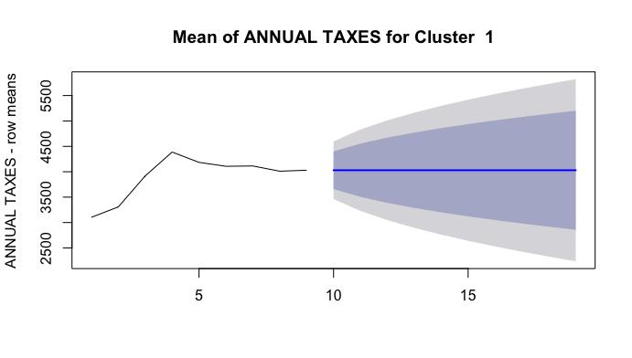

Figure 30: HoltsWinters Simple Exponential smoothing and prediction for cluster 1. The source data mean for years 8 and 9 indicating of problem data set.

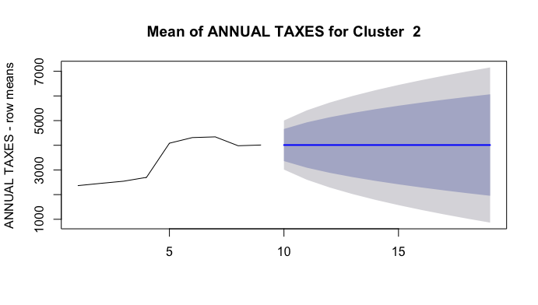

Figure 31: HoltsWinters Simple Exponential smoothing and prediction for cluster 2. The source data mean for years 8 and 9 indicating of problem data set.

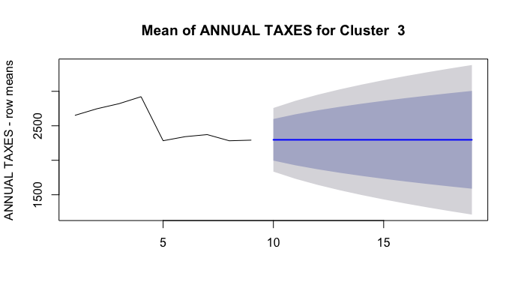

Figure 32: HoltsWinters Simple Exponential smoothing and prediction for cluster 3. The source data mean for years 8 and 9 indicating of problem data set.

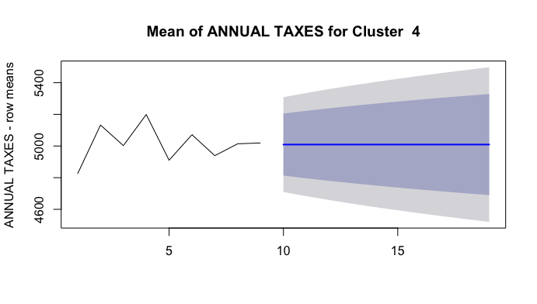

Figure 33: HoltsWinters Simple Exponential smoothing and prediction for cluster 4. The source data mean for years 8 and 9 indicating of problem data set.

For the years 8 and 9, i.e. 2014 and 2015, the taxes were flat. A consultation with the client, CAGIS, also confirmed the observation. It was surmised that batch updates to the Annual Taxes received by the city did not make it to the 2015 tax data .csv files.

**Solution:** It was decided to use data for 8 years instead of 9 years. Also, it was decided to perform the study on Total Market Value (MKT_TOTAL_VAL was selected as a variable) instead of Annual Taxes. An annual tax is assessed on the **Total Market Value**. So, selecting this feature would result in **a better indicator** of the “economic effect” as it **removes the effect** of tax **abatements** and **tax incentives** on certain parcels.

**Problem:** Using HoltWinters on 9 years of annual data

**Holt Winters Filtering**

If one has a time series that can be described using an additive model with increasing or decreasing trend and seasonality, one can use Holt-Winters exponential smoothing to make short-term forecasts. Holt-Winters exponential smoothing estimates the level, slope and seasonal component at the current time point. Smoothing is controlled by three parameters: alpha, beta, and gamma.

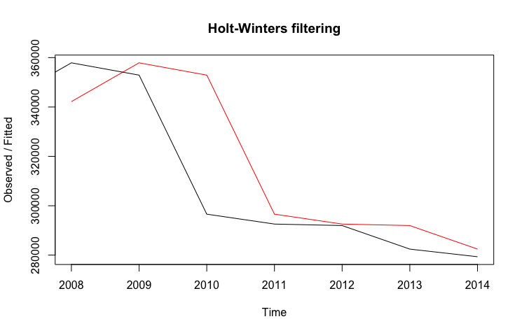

Figure 34: Actual vs. Fitted values of in sample source data. The black line shows the observed in-sample source data for the years 2007 – 2014. The red line marks the fitted data i.e. the prediction of the forecast model.

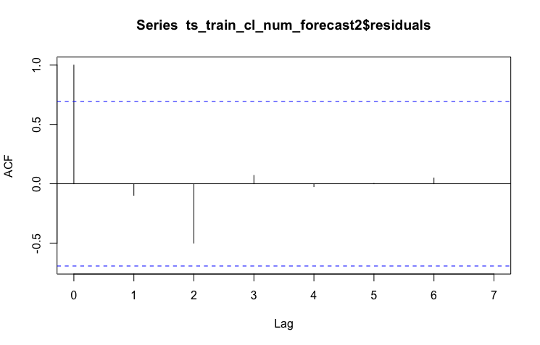

Figure 35: Autocorrelogram indicates that the forecast errors lie within significance bounds. This was the observation for all of the clusters.

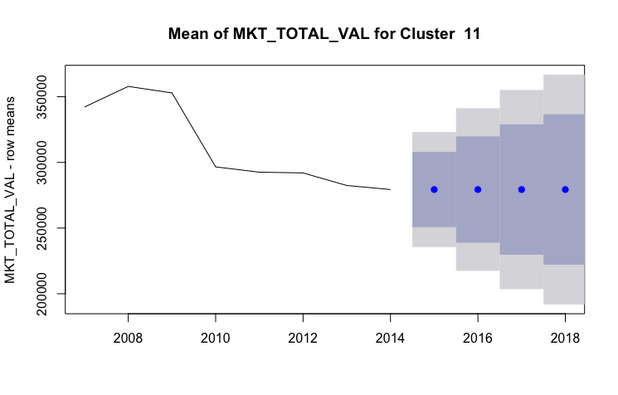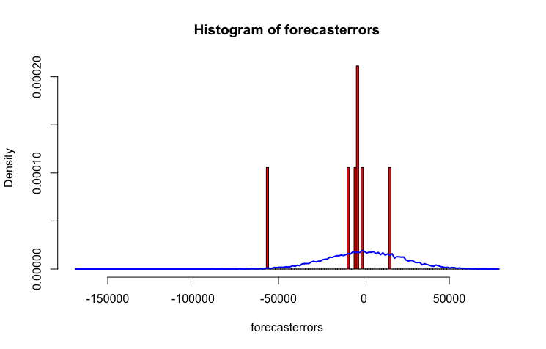

Figure 36: **Left:** Holts Winters Forecast Source data and Forecast data plotted with the 80% and 95% confidence intervals. **Right**: Histogram of forecast errors shows that the variance is not close to 0

In figure 35, even though the auto-correlation function ACF lies within the bounds of significance levels, it is observed in figure 36, that the variance of forecast errors is not zero and therefore, the Holts Winters Exponential method was rejected.

**Solution**: polynomial regression was considered